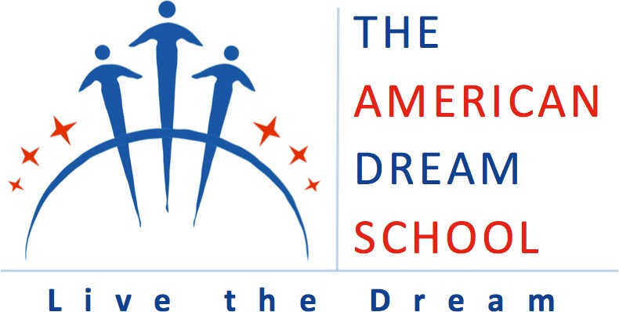

BENCHMARK 1: STUDENT PERFORMANCE

2019 Charter School Performance Framework: The school has met or exceeded achievement indicators for academic trends toward proficiency, proficiency, and high school graduation. Proficiency at the elementary/middle school level shall be defined as achieving a performance level of 3 or higher on all Grade 3-8 assessments. At the high school level, proficiency shall be defined as obtaining a Regents exam score of 65 or higher.

For All Students, and then also for all applicable grade levels served by your school (Elementary/Middle School Outcomes and/or High School Outcomes), please provide a brief narrative describing trends, strengths, weaknesses; a brief rationale for these data outcomes; and strategies the school is employing to improve outcomes for all applicable benchmark standards.

The American Dream School enrolls students as early as sixth grade and they subsequently matriculate through middle and high school and graduate from American Dream at rates that significantly surpass those at traditional high schools in Bronx CSD 7. American Dream also successfully keeps students enrolled and attending school, engaging them in their education and ensuring they are prepared for life beyond high school.

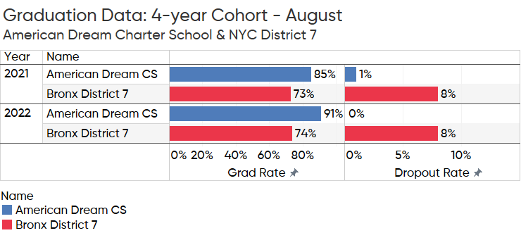

American Dream’s student body is comprised of many high need students, but this doesn’t stop them from achieving academically in alignment with the standards-based curriculum, developing language fluency in both English and Spanish, and advancing into successful colleges and careers. In fact, 41% of the school’s first graduating seniors earned the New York State Seal of Biliteracy in 2021. That rate increased in subsequent years - impressively to 62% in 2022 and 77% in 2023. A remarkable 100% of graduating seniors in 2023 earned the Seal of Civic Readiness. These results are made possible by American Dream’s strong academic program and the extensive social-emotional supports that are offered to students to help each achieve their goals, which often includes enrolling in higher education as the first college-bound generation in their family. The members of the Class of 2023 are headed to colleges and universities ranging from Tufts to Temple University, from Cornell to NYU, many on full or partial scholarships. In fact, the Class of 2023 earned $1,492,698.24 in scholarships.

American Dream Charter School (ADS) falls under the Charter School Office’s 2019 Performance Framework for accountability. The narrative below addresses the various metrics captured by the Performance Framework, along with a few supplemental data points that support a full-term renewal.
2019 Performance Framework Metric 1a(i) – ESEA Accountability Designation
American Dream Charter School has consistently been in good standing. ADS was designated as a school in need of Local Support and Improvement for the 2022-23 school year, and as Good Standing in 2021-22, 2020-21, and 2019-20.
The Seal of Biliteracy is also an important metric for American Dream’s overall accountability. This is relevant as ADS is a dual language school offering a middle and high school program. During the 2022-23 school year, ADS was one of only eight charter schools across New York State offering the New York State Seal of Biliteracy, and one of seven New York City charter schools. Overall, American Dream was one of 473 schools statewide offering this credential. It has recently been estimated that approximately 85 schools in New York City had at least one student earn the Seal of Biliteracy, while approximately 121 offered it as an option. As noted above, 77% of American Dream’s graduates earned this distinction in 2022-23.
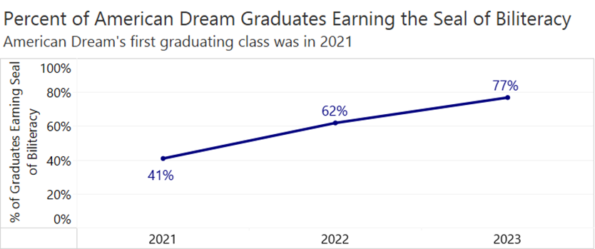
In typical years this data would positively impact the school’s College, Career, and Civic Readiness metrics. According to the state’s accountability resources, due to the unavailability of reliable data in the wake of COVID-19 disruptions, NYSED has not consistently computed the College, Career, and Civic Readiness (CCCR) in recent years. In typical years, however, the Seal of Biliteracy will be very impactful, as according to the publication titled Understanding the New York State Accountability System under the Every Student Succeeds Acts (ESSA), “The College, Career, and Civic Readiness indicator uses diplomas, credentials, advanced course credits and enrollment, Career and Technical Education (CTE) certifications, and indicators such as a Seal of Biliteracy or participation in a Smart Scholars program to determine how a school is preparing its students to be ready for college, a career, and civic engagement once the students leave the school.”
2019 Performance Framework Metric 1b(i) – Similar Schools Comparison
The similar schools analysis provided for the 2022 administration of the 3-8 assessments and the four-year graduation rate show that American Dream’s comparative performance was extremely close to the mean for the ELA and math differential (-1 and -3 respectively). ADS outperformed the mean by a positive differential of +34 in science and +9 for the four-year graduation rate.
2019 Performance Framework Metric 2a(i) and 2a(ii) – Aggregate and Subgroup Trending Toward Proficiency
In the aggregate, ADS students have improved on this metric in English language arts according to the NYSED’s analysis, rising from 41% in 2015-16 to 53% in 2021-22. Importantly, this analysis is based on the percentage of students in the school maintaining a proficient testing level (3 or 4) or trending toward proficiency from one year’s test administration to the next. American Dream first takes students in when they enter sixth grade, and many students have accumulated serious academic deficiencies when they enroll.
Despite this challenge, in 2021-22 (the most recent year of data available) ADS had more than 50% of all students proficient or moving toward proficiency in English language arts (ELA), which is no small accomplishment given students’ prior deficiencies. The ELA rate for English language learners (ELLs) and economically disadvantaged (ED) students was also over 50% for both subgroups in 2021-22. To support students and help them succeed in language arts, and in accordance with the school’s mission, ADS develops students’ abilities to read and comprehend content across subjects in both English and Spanish. Dual language instruction at American Dream is informed by research-based strategies to engage students in high-quality, rigorous instruction using a 50-50 model. Students receive English and Spanish language arts instruction daily. These routines and strategies will continue to be implemented as American Dream works to help students overcome learning losses associated with the disruptions of the pandemic, with high-quality academic and social-emotional support so all students develop dual language academic fluency. A quick glance at the anticipated 2023 New York State test data shows that students have higher proficiency rates in 7th and 8th grade in ELA compared to 6th grade. Grade 7 math is also higher than grade 6 (at ADS 8th grade students take a Regents exam in math).
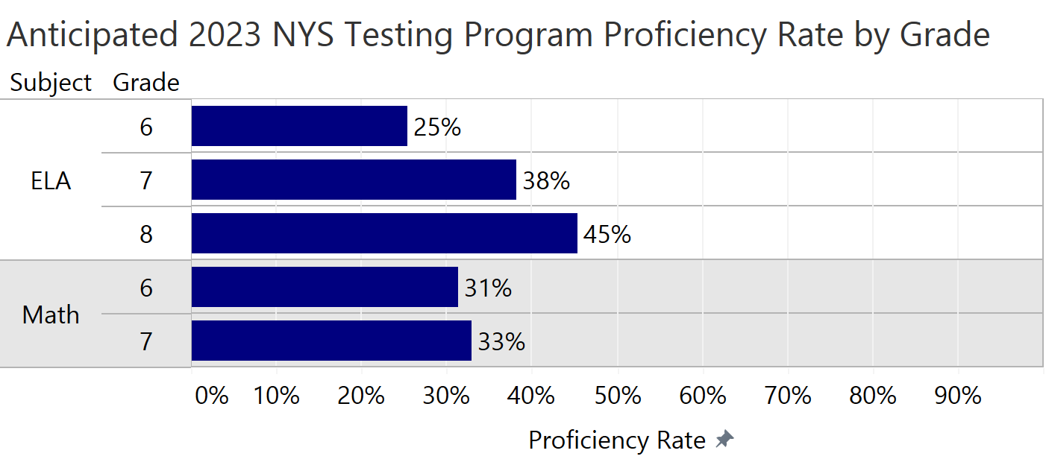
As a subgroup, SWDs did not perform as well on this outcome measure, with 27% recognized as trending toward proficiency in ELA, although as outlined below, the SWD subgroup has strong outcomes on different accountability metrics. To support SWDs, American Dream provides co-teaching in ICT classrooms to provide differentiation and increased opportunities to meaningfully engage, modifications and accommodations as outlined in IEPs or 504 Plans, and a range of services. Students with disabilities are continually supported by a Student Support Team at each campus that includes the Director of Special Populations, Special Education Coordinators, certified special population teachers, and Social Workers/Counselors.
ADS is working to improve on this metric in regard to math performance. In 2021-22, 14% of students aggregated were trending toward proficiency, with subgroup data showing zero for SWDs, 10% for ELLs, and 15% for ED students. As the above graphic depicts, aggregated proficiency in 2023 is expected to be higher in math in 7th grade compared to 6th grade, and students typically take a Regents exam in 8th grade. As previously noted, many American Dream students first enroll with academic remediation needs, particularly in math, and results also reflect the challenges many Bronx students experienced during the height of the pandemic. Staff will continue to address the needs of students and work with them to close performance gaps, with math specialists working in collaboration with classroom teachers and the Student Support Teams to provide interventions. Strategies include interventions focused on number sense, word problems and math fluency, and i-Ready is used to support skill development. American Dream also has hired a math interventionist at the middle school level who will employ tailored instructional strategies to provide targeted support to struggling students, addressing their specific learning needs and fostering mathematical growth. By analyzing student performance data and collaborating with teachers, the interventionist will implement evidence-based interventions to enhance math skills and ultimately contribute to an improvement in our math scores.
2019 Performance Framework Metric 2b(i) and 2b(ii) – Aggregate and Subgroup School Level Proficiency
Despite first enrolling students in middle school, American Dream has outcome data that shows the school outperforms the district consistently in each of the three tested subjects. The analysis for this metric relies on state assessments in elementary/middle school grades in ELA, math, and science. As noted above, these data should not be considered in isolation, as American Dream first enrolls students in 6th grade. In the aggregate, American Dream has outperformed New York City CSD 7 consistently in ELA, math, and science each year since 2015-16.
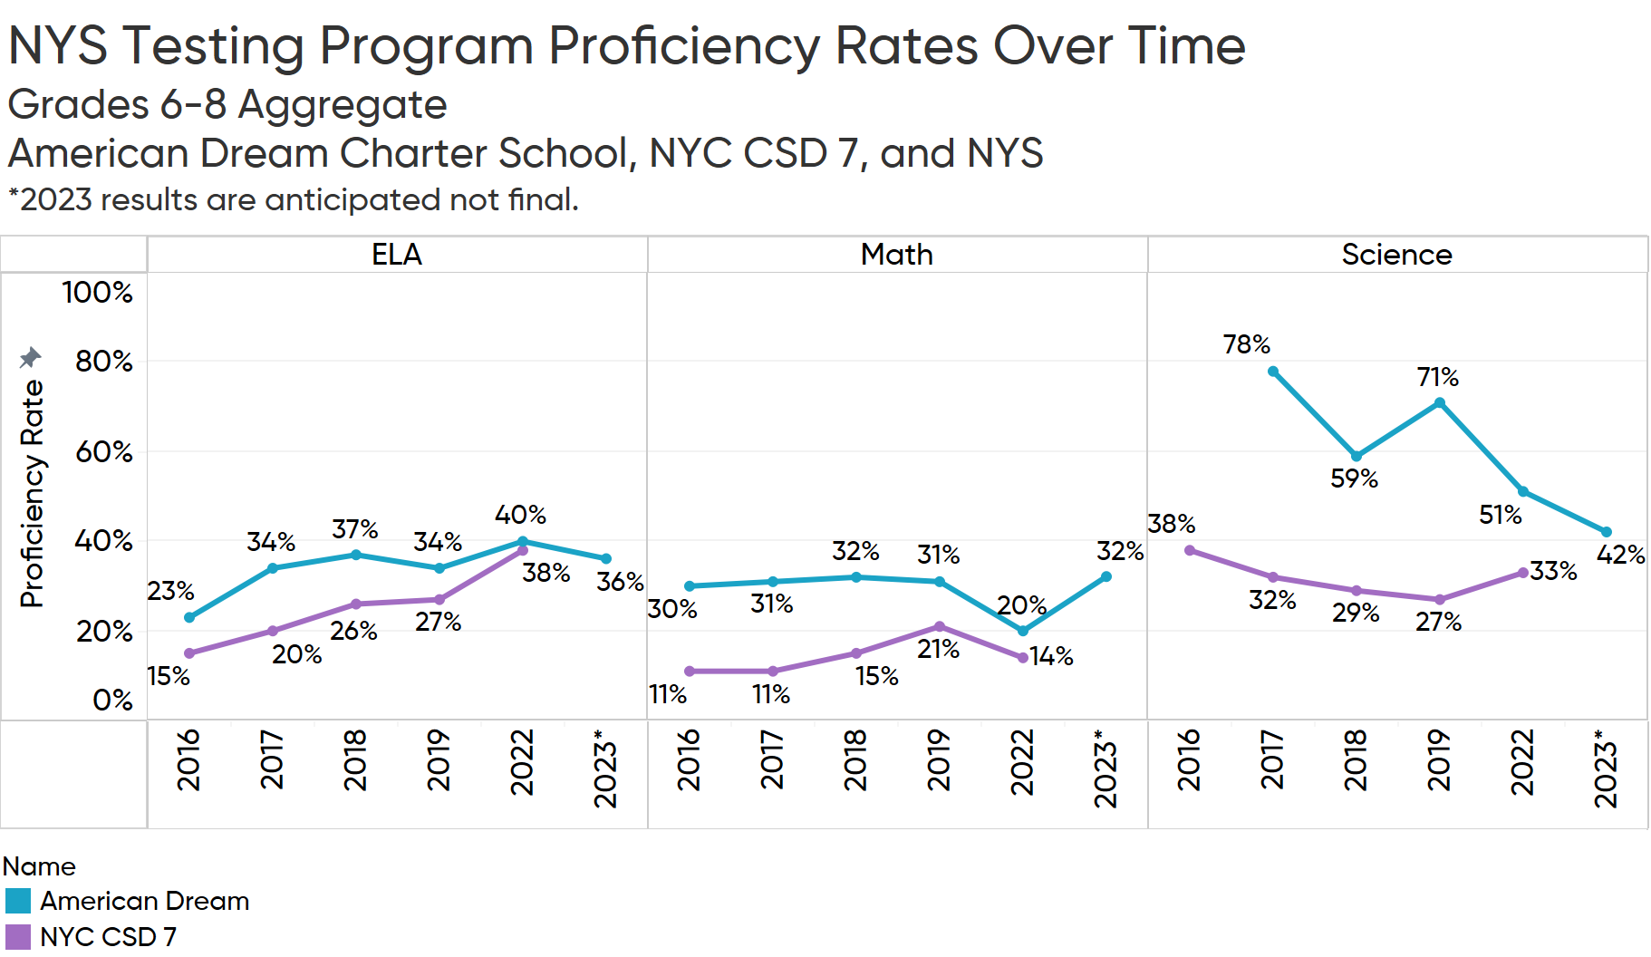
An examination of subgroup performance also shows American Dream’s SWD, ELL, and SWD subgroups have consistently outperformed CSD 7 each year since 2015-16 in ELA, math, and science with only a few exceptions.
Since 2015-16 American Dream has underperformed the state average in ELA and math and has exceeded the state average in science. The underperformance in ELA and math is no surprise given the school’s enrollment configuration (6-12 grades), the performance of CSD 7 schools overall, and American Dream’s location in one of the poorest Congressional Districts in the country. However, the leadership team, staff, and Board strive to meet and exceed the state average as an important accountability indicator.
- Performance Framework Metric 2b(iii) – Aggregate Grade Level Proficiency
The analysis provided by the Charter School Office does not seem to have data tables associated with this accountability metric. The graphic below captures information found in the public database.
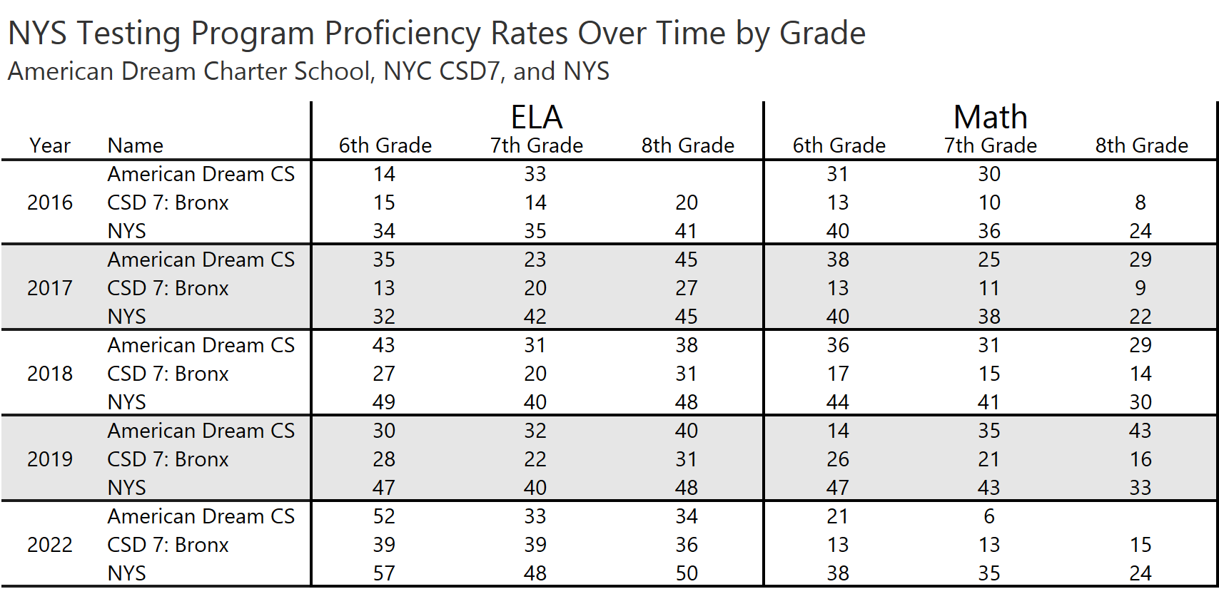
2019 Performance Framework Metric 2b(iv) – Subgroup Grade Level Proficiency
American Dream’s subgroup data reflect generally strong comparative performance over time in ELA, math, and science.
SWDs: In grades 6, 7, and 8, the SWD subgroup outperformed CSD 7 in ELA in each year provided in the analysis with two exceptions: grade 7 in 2021-22 and grade 8 in 2018-19. Overall, the ELA results for the SWD subgroup show a strong performance against the CSD 7 averages, with a positive differential that is often in the double digits. In many instances, ADS outperformed the state average as well, as grade 6 outperformed the state average in ELA in 3 of 5 years, grade 7 outperformed the state average in ELA in 3 of 5 years, and grade 8 outperformed the state average in ELA in 2 of 3 years.
In math, the SWD subgroup outperformed CSD 7 on the grade level analysis each year with just two exceptions. Further, the SWD subgroup outperformed the state average in every instance with only three exceptions. In science, the SWD subgroup outperformed both CSD 7 and the state by large differentials.
ELLs: In a majority of grades and years the ELL subgroup outperformed CSD 7 and the state average in ELA. The same is true for math. Notably, by the time ELL students reach 8th grade they typically outperform the state average in both subjects. In both ELA and math, American Dream’s 8th grade ELL students beat the state average in three of four years of data provided. In science, the 8th grade ELL students at American Dream outperformed CSD 7 and the state by large positive differentials in every year reported.
EDs: In each year reported, with only one exception, American Dream’s ED subgroup outperformed CSD 7 in ELA in grades 6, 7, and 8. Further, in half of all reported years and grades the ED subgroup outperformed or was on par with the state average in ELA. In math the subgroup outperformed CSD 7 in all but two instances and outperformed the state in all but three instances. The data for science is consistent with ELA and math, as American Dream’s ED students outperformed both the district and the state in 8th grade every year.
2019 Performance Framework Metric 3a(i) and (ii) – Regents Examination Outcomes
American Dream’s aggregate total cohort Regents outcomes are strong. Student outcomes have outperformed the district, and American Dream’s students have participated in Regents exams at a much higher rate than the CSD 7 average as well. The following graphic was developed using data available through the public files and does not include students who were exempt/tested or exempt/not tested.
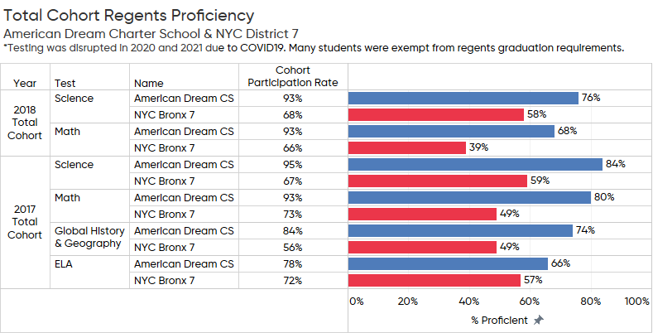
A review of the data provided by the Charter School Office highlights how many Regents exams are offered by American Dream. The results also reflect strong proficiency rates over time. At American Dream, students consistently have access to rigorous courses and pathways for graduation. This access to advanced coursework aligns with the mission and is consistent with the school’s Advanced Placement offerings. ADS offers seven Advanced Placement courses: Calculus, Spanish Language and Culture, Spanish Literature and Culture, English Language and Composition, Biology, Chemistry, and US History.
Anticipated 2023 Regents data are as follows – these data should also be considered in the context of the post-pandemic learning environment in the Bronx.
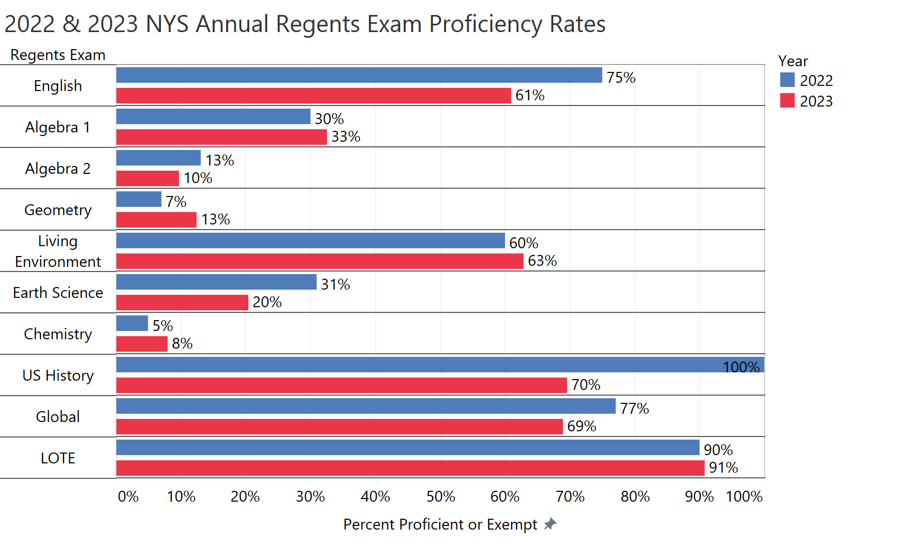
*The anticipated 2023 results do not include exemptions.
The proficiency rates in 2022 and the expected proficiency rates in 2023 demonstrate the challenges American Dream’s student body experienced due to the pandemic’s extreme impact on the Bronx in spring 2020 and throughout the 2020-21 school year. While there are many highlights to celebrate – including incredibly high passage on LOTE exams, which explicitly aligns with the school mission – these data also show the school must, and will, continually work to ensure students have the supports they need to reflect the proficiency rates that were common for ADS prior to the pandemic. Also of note is that American Dream’s staff expect and encourage all eligible students to sit for each Regents exam. There are no efforts to minimize the number of students tested based on anticipated outcomes, and that is also important context to bear in mind while reading the results. This reflects the American Dream culture, which values providing the student body access and opportunity to rigorous coursework and their associated exams, which is important considering the school’s high-need, historically under-represented enrollment demographics.
NYSED’s analysis shows how the ED, ELL, and SWD subgroups performed against the state average during 2017-18 through 2021-22 on each of the administered Regents exam. In many instances the ADS subgroups did outperform the state average. Through intentionally planned differentiation, thoughtful and rigorous professional development opportunities, collaborative Data Days that are held to examine assessment results and plan accordingly, and the provision of impactful interventions, each student is supported academically and socially/emotionally by American Dream’s committed staff. These routines support student success.
Turning to the NYSED’s analysis of the aggregate and subgroup 4-year cohort outcomes, it is clear American Dream brings immense value to the students it serves. In the aggregate, American Dream’s cohort results for the 2017 and 2018 cohorts show that in ELA, Global History, Math, and Science, ADS met or exceeded the state average in all but one instance, and in that instance, it was very close (85% compared to 87% for the 2017 cohort on the Global History exam). Further, the SWD, ELL, and ED subgroups met or outperformed the state average in every instance on those exams – often by very large positive differentials. The only exam where American Dream’s cohorts underperformed the state average was in US History.
2019 Performance Framework Metric 3a(iii) and (iv) – College and Career Readiness
NYSED did not report on this metric in Attachment 1, however, supplemental data are provided here to provide additional evidence of American Dream Charter School’s positive impact and performance. First, as a reminder, in 2023, 77% of American Dream’s graduates earned the Seal of Biliteracy and 100% of graduates earned the Seal of Civic Readiness.
Additionally, American Dream is proud to have been recognized by the College Board for the 2022-23 AP Honor Roll. This designation was created to recognize schools that have done outstanding work to welcome more students into AP courses and support them on the path to college success. The metrics examined by the College Board to grant Honor Roll status include an examination of College Culture, College, Credit, and College Optimization.
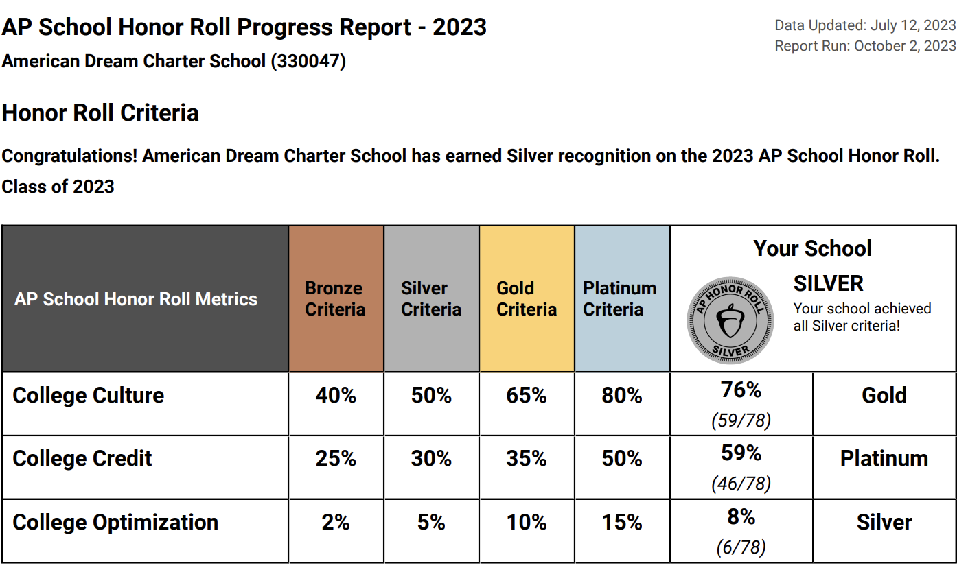
In addition to being placed on the Honor Roll, American Dream also was granted the Access Award.
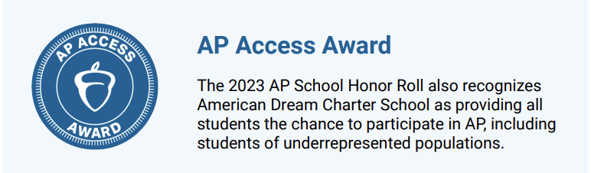
The recognition letter from the College Board states:
“Your school is being further recognized with the AP Access Award, which honors schools that encourage more low-income and underrepresented minority students to take AP courses. The percentage of students in at least one of these categories who took at least one AP Exam before graduation is proportional to or above your school's student population, demonstrating a clear and effective commitment to equitable access to advanced coursework.”
ADS routinely provides students with access to multiple Advanced Placement (AP) courses: Calculus, AP Pre-Calculus, Spanish Language and Culture, Spanish Literature and Culture, English Language and Composition, Biology, Chemistry, and US History. The College Board states that even if students do not earn college credit at the end of an AP course, there is immense value in having participated in the advanced coursework, which provides early exposure to college-level work and contributes to a college-going school culture. This is supported by American Dream’s college acceptance and matriculation rates, which clearly demonstrate graduates are provided what they need, both academically and socially, to pursue opportunities in higher education.
College Acceptances by Class
- Class of 2021: 63 students (100% Received College Acceptances)
- Class of 2022: 82 students (100% Received College Acceptances)
- Class of 2023: 78 students (99% Received College Acceptances)
College Matriculation by Class
** The data below represents the students who committed and enrolled in their respective colleges as of June 2021, 2022, and 2023. **
- Class of 2021: 59 students (94% Went to College)
- Class of 2022: 78 students (95% Went to College)
- Class of 2023: 74 students (95% Went to College)
Finally, results for the AP Spanish exams are particularly noteworthy, as they are critically aligned to the school’s mission and identity as a dual language school that promotes linguistic and cultural fluency in both English and Spanish.
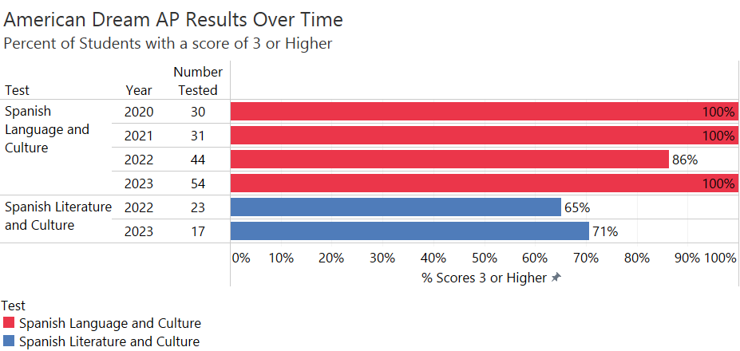
2019 Performance Framework Metric 3b(i) and (ii) – Aggregate and Subgroup Cohort Graduation Rates
With only one exception, each of American Dream’s cohorts examined in this analysis outperformed the state average. This is incredibly meaningful considering American Dream’s mission and location in the South Bronx; this metric is a high bar to clear as the state average includes the most privileged communities across New York in the data. Further, in every instance reported in the analysis, the graduation rates for the SWD, ELL, and ED subgroups outperformed the state average as well. The only reported metric where American Dream did not outperform the state was the 2017 four-year cohort in the aggregate, and in that instance, ADS was essentially on par with the state average, 85% compared to 86%.
2019 Performance Metric 3b(iii) and (iv) – Aggregate and Subgroup Cohort On-Track to Graduate
NYSED reported on three cohorts for this analysis, the 2017, 2018, and 2019 cohorts. ADS outperformed expectations in each instance, including all students in the aggregate as well as all reported subgroups.

https://www.nysed.gov/sites/default/files/programs/world-languages/nyssb-handbook.pdf

