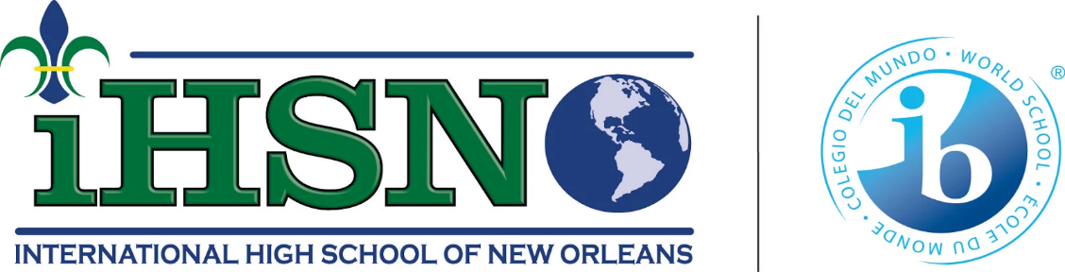
Academics Committee Meeting
January 2024

Highlights
● All staff finished packing on time for the move, teachers settled in their classrooms, and facilities worked on responding to maintenance requests to ensure classrooms were conducive to the learning environment.
● We filled positions for Spanish, English, and English Language Learner teachers and a Special Education Coordinator. They are all great additions to the academic team.
● Significant participation of new parents during PTO meetings in December and January. There is an increase in participation in meetings due to the active leadership of the PTO president and the initiatives to have more fundraising activities throughout the year.
- The coat and blanket drive organized by the social workers has helped about 40 students who need outerwear during this cold season.
- January open house was well attended and organized. Families who attended have the link to enroll in NOLA to complete early applications for admissions for the 2025-2026 school year.

Projects and updates

Curriculum updates
- Teachers received the simplified lesson plan template for teachers sharing their exit ticket questions. The goal is to streamline the time and focus of teachers to follow the data from the exit tickets to plan for reteaching main ideas and standards.
- Teachers received virtual training in Fast Forword. Fast Forword is a learning platform to enhance literacy for all students. Students will use the platform during advisory and enrichment time.
- Math teachers are using the tier 1 curriculum “Illustrative Math” with fidelity. The Principal is working with the state to improve planning, preparation, and student outcomes in Algebra I and Geometry, which impact LEAP test results.
- The principal conducted formal observations and held their respective pre and post-conferences. The trend of the observations is the need for more training in questioning techniques and engaging students. These topics will be the main focus of Semester II Professional Development.

Departmental Updates
- Due to the lack of Wi-Fi in the new facility, we have to re-schedule the training for Middle Years Program planning and English Language Learners training. There was still training for culture expectations reset with faculty on January 4th. Teachers review expectations about uniforms, hall passes, attendance, duty schedules, and Capturing Kids Hearts social contracts.
- Adjustments have been made to the IB internal due dates to ensure that all International Baccalaureate (IB) internal deadlines for Internal Assessments are met.
- The Special Education internal audit was conducted in December, we identified students with former Individual Education Plans (IEPs) needing to be reinstated. The new Coordinator of Special Education Services is working to ensure that all students are identified for services, either 504 plans or IEPs.
- As part of our commitment to ensuring that dual enrollment students succeed academically and are on track for graduation, counselors have devised a plan to have periodic check-ins with dual enrollment students, colleges, and families.

IB Updates
- Important dates for the 2023-24 academic year released, including March 15 for HL Essay, ToK Essay, Extended Essay, and Group 6 early submissions, and IB May 24 (M24) exam schedule are now in the calendar and have been communicated to students and families.
- Mock exams are recommended for each senior DP class to familiarize students with the structure of course exams in the M24 session. IB DP faculty is working on creating and proctoring mock exams for all IB seniors.
- Several initiatives have been proposed to incentivize IB DP students, including a Semester Quarterly Celebration, IBDP Dress Down, extra library access, and wearing senior t-shirts for only IBDP candidates.

Culture Updates
- Culture has been holding Saturday detention. Most Saturday detention involves uniform violations, cell phone usage, or skipping. The culture team is developing a PBIS reward system to motivate students to follow the policies to have an environment free of distractions.
- The culture team conducted student assemblies to re-iterate the expectations for all grade levels. Students will continue having student assemblies twice a month to present information regarding culture, students’ quarterly awards, counseling and scholarship opportunities, and general updates.

Upcoming events
- TET Celebration February 8th
- Black History Celebration February 28
- Mardi Gras Break February 12th to 16th
- Work Keys Test February 22nd and 23rd.
- PTO meeting February 20th, 6:00 pm

