4/10/2024
Life Academy started ACAP Summative testing on 4/2/2024.
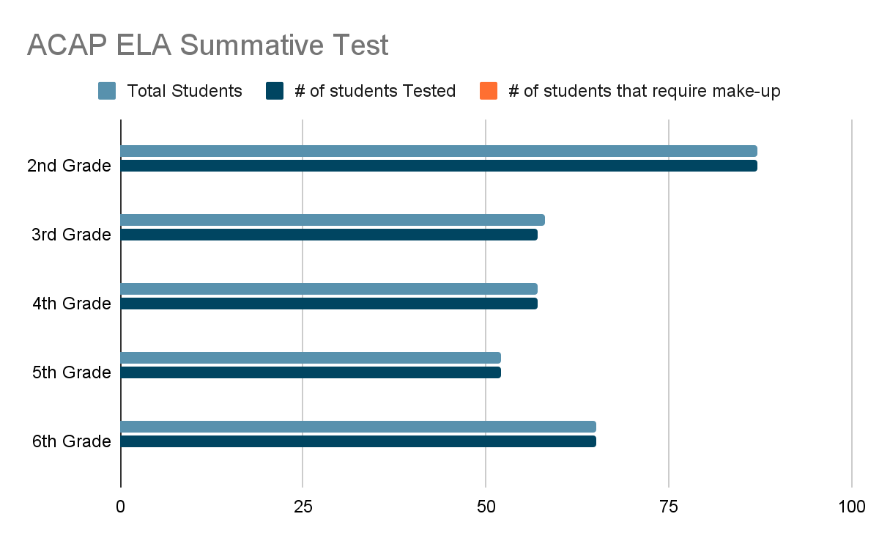
 | 2nd Grade | 3rd Grade | 4th Grade | 5th Grade | 7th Grade
Total # students | 87 | 58 | 57 | 52 | 65
# of students tested | 87 | 58 | 57 | 52 | 65
# of students that require make-up | 0 | 0 | 0 | 0 | 0

The ACAP ELA Summative Test was given to 2nd and 3rd grade students on April 2nd and April 3rd. There were multiple make-up days built into the testing schedule. The 2nd and 3rd grade ELA tests had to be completed by Apr 12, 2024. The testing window for Life Academy will end on April 19, 2024. As of April 12, 2024, we have tested 100% of the students in grades 2-6 in ELA. The math test started on April 12, 2024 for grades 2 and 3. Math will be given for grades 4-6 on Monday, April 15, 2024 and Science for grades 4 and 6 on Tuesday April 16, 2024. April 17-19 are testing make-up days for the students that were absent.

Tonya Hardy Moore, Ed.S
MTSS Coordinator/Curriculum Specialist

