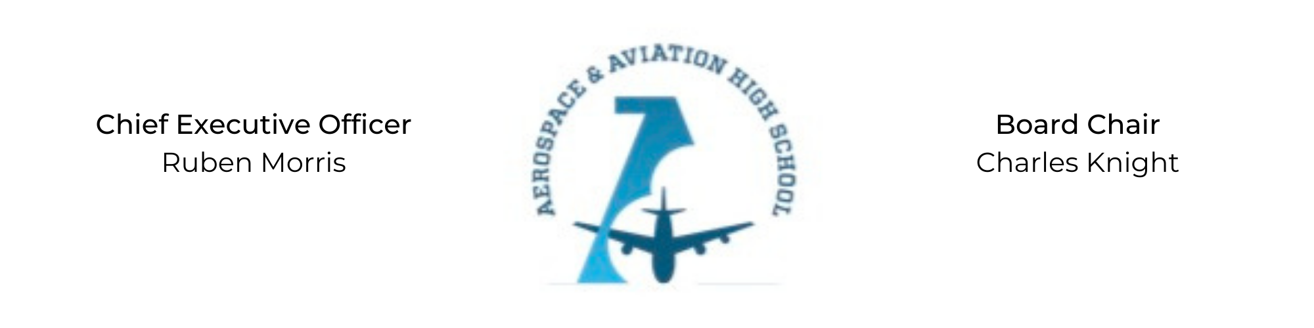
REGULAR MEETING OF THE BOARD OF DIRECTORS
Tuesday, October 25, 2022
3:30 PM
AGENDA

- Call to Order - Chair Knight
- Roll Call & Establishment of Quorum
ALAAHS Board Members: Auri Brown, Courtney French, Charles Knight, Luis Pineda, Tramayne Russell, Merrick Sims, Jeff Smith, R.J. Smith, Scott Underwood, Jeff Walker, Phaye Wilson, Tierra Wright
- Adoption of the Agenda
- Adoption of the Minutes - September 20, 2022
- Financial Report
- Chief Executive Officer’s Report
- Old Business
- New Business
- Adjournment

