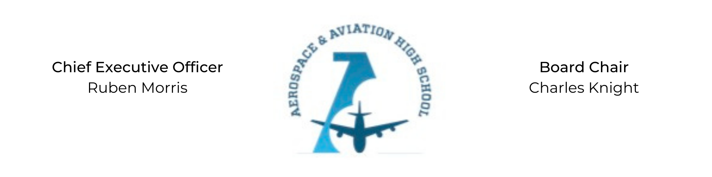
REGULAR MEETING OF THE BOARD OF DIRECTORS
Tuesday, February 28, 2022
3:30 PM
AGENDA
- Call to Order - Chair Knight
- Roll Call & Establishment of Quorum
ALAAHS Board Members: Courtney French, Charles Knight, Luis Pineda, Tramayne Russell, Merrick Sims, Jeff Smith, R.J. Smith, Scott Underwood, Jeff Walker, Phaye Wilson, Tierra Wright
- Adoption of the Agenda
- Adoption of the Minutes - January 31, 2023
- Financial Report, R.J. Smith and Ruben Morris
- Academic Update, On’Draya Green
- Facility Update, New Schools Facility Partner
- Chief Executive Officer’s Report
- Consent Calendar
  - Resolution 2023-2 - Resolution to approve contract for services.
  - Resolution 2023-3 - Resolution to contract services with DJ Retro for the AAHS Masquerade Ball.
  - Resolution 2023-4 - Resolution to contract services with Kathy King-Harris Events for the AAHS Masquerade Ball.
  - Resolution 2023-5 - Resolution to contract services with Party Next Door for the AAHS Masquerade Ball.
- Resolutions for Consideration and Approval
- Old Business
Nominations for Board Secretary
- New Business
- Adjournment

