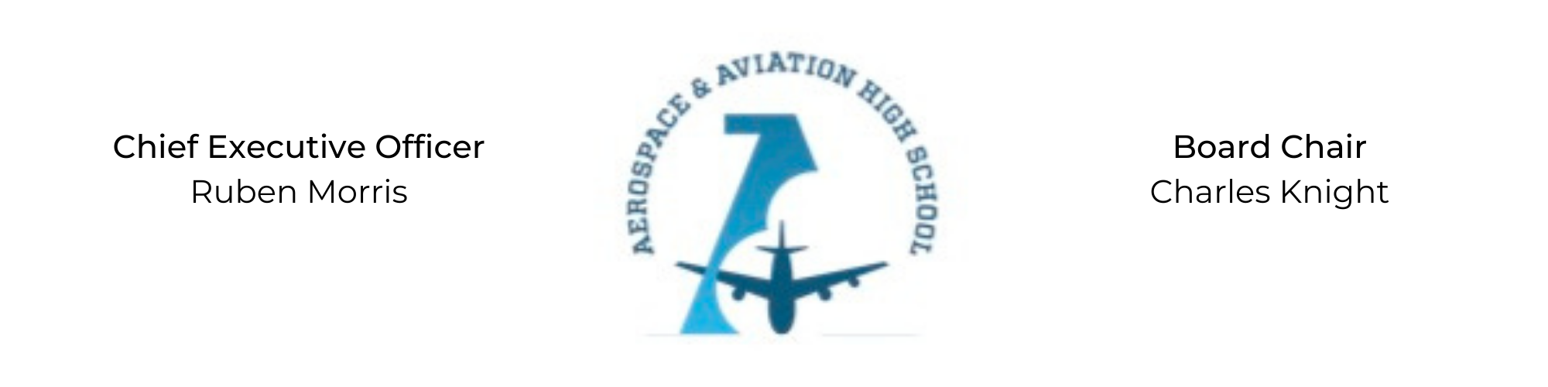
REGULAR MEETING OF THE BOARD OF DIRECTORS
Tuesday, January 31, 2022
3:30 PM
AGENDA

- Call to Order - Chair Knight
- Roll Call & Establishment of Quorum
ALAAHS Board Members: Courtney French, Charles Knight, Luis Pineda, Tramayne Russell, Merrick Sims, Jeff Smith, R.J. Smith, Scott Underwood, Jeff Walker, Phaye Wilson, Tierra Wright
- Adoption of the Agenda
- Adoption of the Minutes - November 29, 2022
- Financial Report
- Chief Executive Officer’s Report
- Consent Calendar
  - Resolution 2023-1 - Approval of a resolution to update policies in the Student and Family Handbook.
- Resolutions for Consideration and Approval
- Old Business
- New Business
- Adjournment

