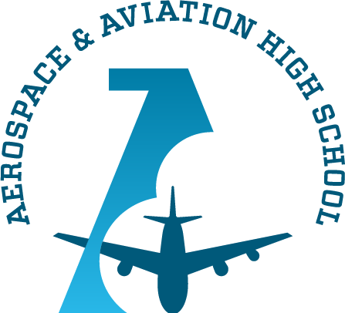
Alabama Aerospace and Aviation High
School Board Meeting
August 30, 2022 @ 3:30 PM
I. Welcome, Mr. Charles Knight
II. Approval of Agenda, Mr. Charles Knight
III. Review of August 23rd Meeting Minutes, Ruben Morris and Auri Brown
IV. Budget Vote, Ruben Morris
V. SEL Vote, Mr. Ruben Morris, CEO/Head of School

VI. Adjourn, Mr. Charles Knight

