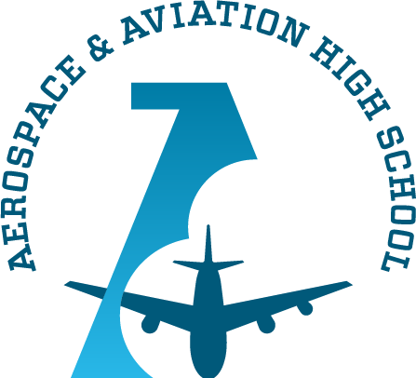
Alabama Aerospace and Aviation High
School Board Meeting
July 19, 2022 @ 3:30 PM
I. Welcome, Mr. Charles Knight
II. Approval of Agenda, Mr. Charles Knight
III. Review of April and May Meeting Minutes, Ruben Morris and Auri Brown
IV. Financial Report, Mr. Ruben
Morris, CEO/Head of School and RJ Smith, Treasurer
V. Head of School Report, Mr. Ruben Morris, CEO/Head of School
a) Head of School
Remarks
i. Facility Update
ii. Grant Funding Report/CSP Grant Budgeting Report
iii. Student Recruitment/Enrollment Report
iv. Contract Resolutions

VI. Board Member Transition

VII. Adjourn, Mr. Charles Knight

