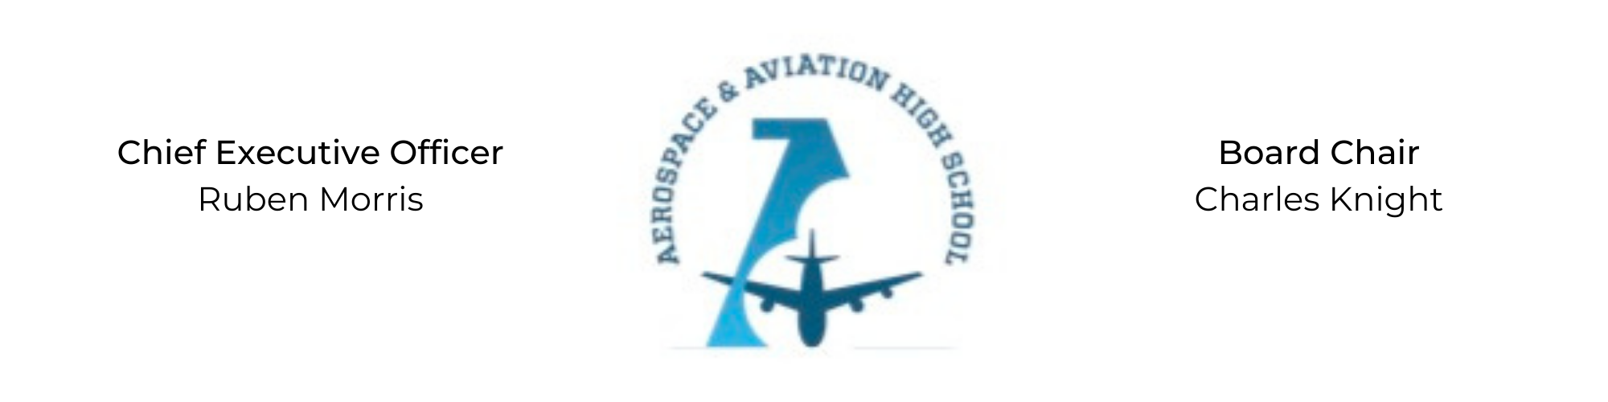
REGULAR MEETING OF THE BOARD OF DIRECTORS
Tuesday, February 28, 2022
3:30 PM
Minutes

- Call to Order - Chair Knight
Charles Knight called the meeting to order at 3:35 PM.
- Roll Call & Establishment of Quorum
Leadership and Board Members in attendance: Courtney French, Charles Knight, Ruben Morris, Luis Pineda, Jeff Smith, R.J. Smith, Scott Underwood, Phaye Wilson, Tierra Wright, Jillian Fitts (Assistant to the Board)
Guests: Phillip Campbell(New School Facility Partners), Scott Burnett(CCR Architecture & Interiors), On’Draya Green (Dean of Culture & Instruction)
Absent: Tramayne Russell, Merrick Sims, Jeff Walker
- Adoption of the Agenda
Charles Knight moved to approve the February agenda. None opposed.
- Adoption of the Minutes - January 31, 2022
R.J. Smith moved to approve the January 31st minutes, Courtney French seconded and the motion carried.
Luis Pineda joined the meeting via Zoom at 3:39 pm.
- Financial Report
R.J. Smith presented the treasurer’s report for January 2023. R.J. Smith moved to accept the treasurer’s report. Phaye Wilson seconded and the motion was carried.
Jeff Smith joined the meeting via Zoom at 3:40 pm.
- Academic Update, On’Draya Green
- Facility Update, Phillip Campbellwith New School Facility Partners and Scott Burnettwith CCR Architecture & Interiors
- Chief Executive Officer’s Report
- Consent Calendar
  - Resolution 2023-2 - Resolution to approve various contracts for services for the students’ Masquerade Ball.
- Resolutions for Consideration and Approval
R.J. Smith moved to approve the 2023-2 Resolution to approve the contracts for services for the students’ Masquerade Ball and was seconded by Tierra Wright. The motion passed unanimously.
- Old Business
- Nominations for for Board Secretary: Charles Knight nominated Phaye Wilson for Board Secretary and was seconded by Jeff Smith. The motion was carried unanimously.
- New Business
Next month’s meeting will be Tuesday, March 20th at 3:30 PM.
- Adjournment
The meeting adjourned at 4:54 PM.

Respectfully submitted,
Jillian L. Fitts

Approved by: Approved by:

________________________________ _________________________________
Board Chairman Board Secretary

