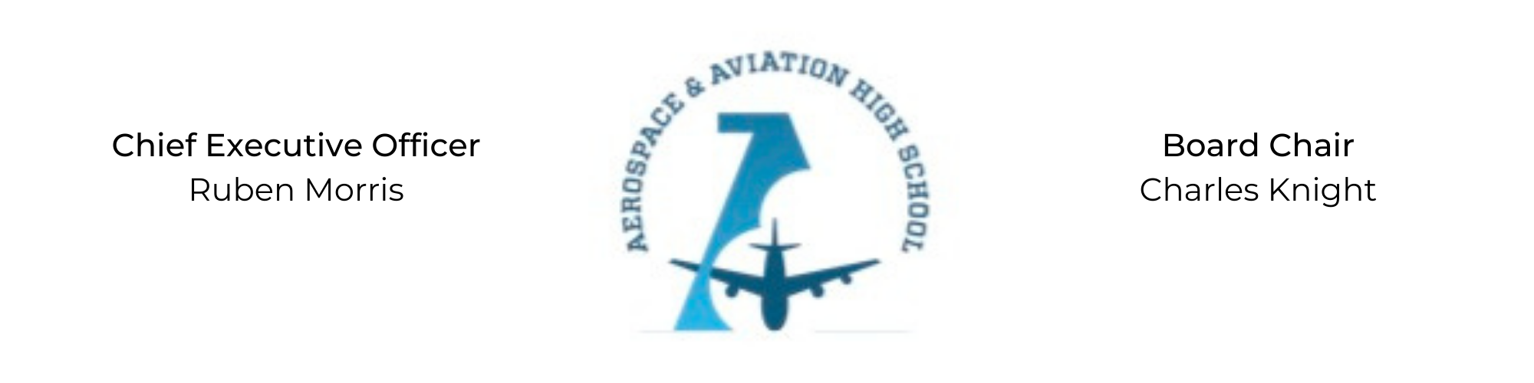
REGULAR MEETING OF THE BOARD OF DIRECTORS
Tuesday, January 31, 2022
3:30 PM
Minutes

- Call to Order - Chair Knight
  - Charles Knight called the meeting to order at 3:34 PM.
- Roll Call & Establishment of Quorum
Leadership and Board Members in attendance: Charles Knight, Ruben Morris, Tramayne Russell, Merrick Sims, Jeff Smith, Phaye Wilson, Tierra Wright, Jillian Fitts (Assistant to the Board)
Absent: Courtney French, Luis Pineda, Scott Underwood, Jeff Walker
- Adoption of the Agenda
R.J. Smith motioned to approve the January agenda. Tierra Wright seconded and the motion carried.
- Adoption of the Minutes - November 29, 2022
Tramayne Russell moved to approve the November minutes, Tierra Wright seconded and the motion carried.
Phaye Wilson joined the meeting via Zoom at 3:36 pm.
- Financial Report
R.J. Smith presented the fiscal year end report for 2022.
- Chief Executive Officer’s Report
- School Update: Current enrollment is 90 students and next year minimum enrollment is 200. Launched 21st Century Afterschool program open to our students as well as children in the community.
- Grant Update: We have applied for $275k from various philanthropic groups.
- Staff Update: Teacher and staff positions for the ‘23-’24 year have been posted. Auri Brown, former Secretary for the Board, has joined the AAHS staff as a paraprofessional.
- Facility Update: Converted the gymnasium at our current facility to a hangar. Proposed remodel for upstairs being voted on by the Church.

- Consent Calendar
  - Resolution 2023-1 - Approval of a resolution to update policy 5.5, Erin’s Law, the Safe School Equipment and Facilities, Laboratories and Policies, as well as, the Physical Restraint policy in the Student and Family Handbook.
- Resolutions for Consideration and Approval
Jeff Smith moved to approve the 2023-1 Resolution to update policies in the Student and Family Handbook and seconded by R.J. Smith
- Old Business
No old business.
- New Business
Charles Knight nominated Phaye Wilson to be Secretary for the Board. R.J. Smith seconded. The motion was tabled.
Next month’s meeting will be Tuesday, February 28th at 3:30 PM.
- Adjournment
R.J. Smith motioned to adjourn, seconded by Tierra Wright. The motion was carried and the meeting adjourned at 4:42 PM.

Respectfully submitted,
Jillian L. Fitts

Approved by: Approved by:

________________________________ _________________________________
Board Chairman Board Secretary

