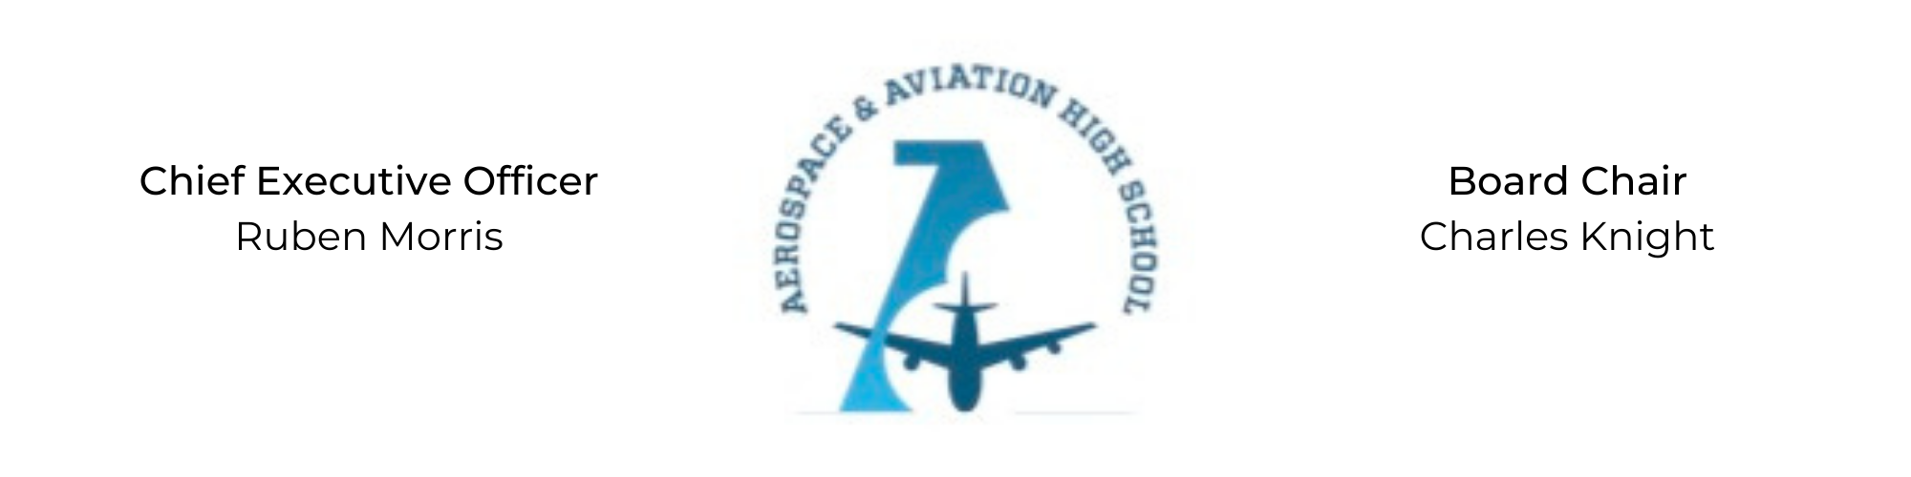
REGULAR MEETING OF THE BOARD OF DIRECTORS
Tuesday, November 29, 2022
3:30 PM
Minutes

- Call to Order - Chair Knight
  - Charles Knight called the meeting to order at 3:33 PM.
- Roll Call & Establishment of Quorum
Leadership and Board Members attending virtually: Auri Brown, Courtney French, Charles Knight, Ruben Morris, Luis Pineda, Merrick Sims, Jeff Smith, Scott Underwood, Phaye Wilson, Tierra Wright, On’Draya Green (Dean of Culture and Instruction), Jillian Fitts (Assistant to the Board)
Absent: Tramayne Russell, R.J. Smith, Jeff Walker
- Adoption of the Agenda
Ruben Morris asked to hold off on the financial report until next month when the treasurer, R.J. Smith, could be present.
Merrick Sims moved to approve the agenda, Tierra Wright seconded and the motion carried.
- Adoption of the Minutes - October 25, 2022
Scott Underwood moved to approve the October minutes, Merrick Sims seconded and the motion carried.
- Financial Report
Financial Report moved to next month’s meeting when the treasurer can be present.
- Academic Report
On’Draya Green, Dean of Culture and Instruction, presented academic growth results from the ‘22 Fall Semester.
Phaye Wilson joined the meeting via Zoom at 3:40pm.
Courtney French joined the meeting via Zoom at 3:40pm.
Luis Pineda joined the meeting via Zoom at 3:45pm.
- End-of-Year Giving Report
Phaye Wilson presented a plan for the end of the year fundraiser, with a goal of $107k, and a corresponding newsletter.
- Chief Executive Officer’s Report
- Facility Update: $30,000 of capital funds used for an aviation workshop. Working on an estimate to outfit a few upstairs labs with walls and internet.
- Legislators’ visit on Jan 5 from noon to two.
- Grant Update: Launching a recurring fund that will be funded by the Colemans. There are a couple of $100k grants that we are in the middle of the application process.
- School Update: Sports include a JV Basketball team, an EA sports team and the drone soccer team. Recruitment has started and expected enrollment for the ‘22-’23 year is 250-300.
- Old Business
No old business.
- New Business
No new business.
- Adjournment
Auri Brown motioned to adjourn, seconded by Scott Underwood. The motion was carried and the meeting adjourned at 4:15 PM.

Respectfully submitted,
Jillian L. Fitts

Approved by: Approved by:

________________________________ _________________________________
Board Chairman Board Secretary

