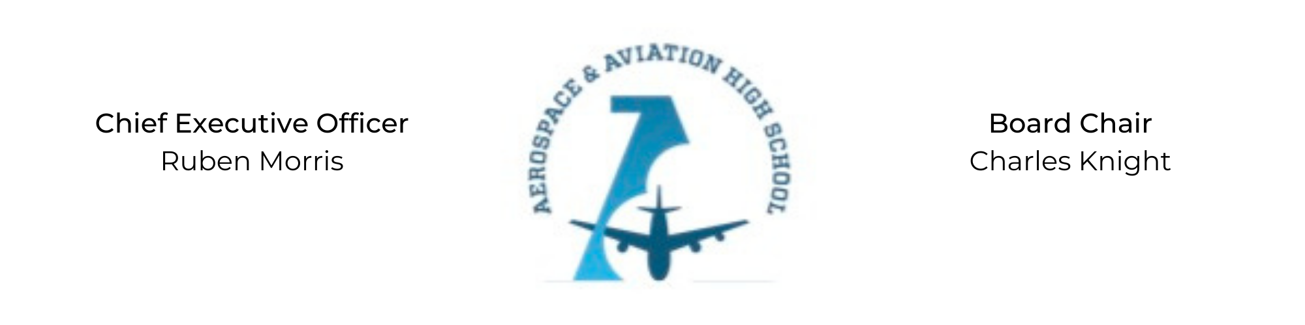
REGULAR MEETING OF THE BOARD OF DIRECTORS
Tuesday, September 20, 2022
3:30 PM
Minutes

- Call to Order - Chair Knight
  - Charles Knight called the meeting to order at 3:35 PM.
- Roll Call & Establishment of Quorum
Leadership attending in person: Ruben Morris, Charles Knight
Board Members attending virtually: Auri Brown, Courtney French, Luis Pineda, Merrick Sims, Jeff Smith, R.J. Smith, Phaye Wilson
Guests: Scott Underwood
Absent: Tramayne Russell, Jeff Walker, Tierra Wright
- Adoption of the Agenda
Phaye Wilson moved to approve the agenda, Jeff Smith seconded and the motion carried.
- Adoption of the Minutes - August 30, 2022
Jeff Smith moved to approve the August minutes, Phaye Wilson seconded and the motion carried.
- Financial Report
- Chief Executive Officer’s Report
  - School enrollment is at 100 students: 80 9th grade students and 20 10th grade students.
  - Sanders Capital donated $40,000 and committed to feeding the entire staff once a month.
Courtney French joined the meeting virtually at 3:46 PM.
Luis Pineda joined the meeting virtually at 3:50 PM. Quorum reached.

  - A United Pilot donated a fully operable aircraft and the Bessemer airport will donate 6 months free rent and storage.
RJ Smith joined the meeting virtually at 3:54 PM.
- Old Business
Charles Knight had previously nominated Scott Underwood to the Board. Jeff Smith motioned to approve the nomination and Phaye Wilson seconded the motion. The motion was carried unanimously.
- New Business
Charles Knight asked for a motion to honor Dr. David Marshall at the upcoming Excellence Dinner. Courtney French motioned to approve the honoree and RJ Smith seconded the motion. The motion was carried unanimously.
- Adjournment
  - Courtney French motioned to adjourn, seconded by Scott Underwood. The motion carried and the meeting adjourned at 4:30 PM.

Respectfully submitted,
Jillian L. Fitts

Approved by: Approved by:

________________________________ _________________________________
Board Chairman Board Secretary

