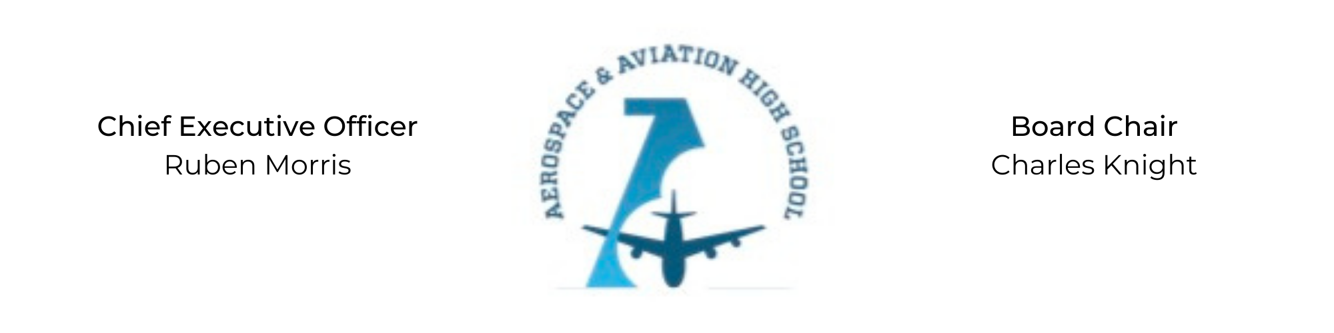
SPECIAL CALLED MEETING OF THE BOARD OF DIRECTORS
Tuesday, August 30, 2022
3:30 PM
Minutes

- Call to Order - Chair Knight
  - Charles Knight called the meeting to order at 3:34 PM.
- Roll Call & Establishment of Quorum
Leadership and Board Members in attendance: Auri Brown, Courtney French, Charles Knight, Ruben Morris, Luis Pineda, Tramayne Russell, R.J. Smith, Jeff Walker, Phaye Wilson, Tierra Wright, Jillian Fitts (Assistant to the Board)
Guests: Russell Raney (CFO), Chris Reynolds (NSFA)
Absent: Merrick Sims and Jeff Smith
- Adoption of the Agenda
R.J. Smith motioned to approve the August 30th agenda. Jeff Walker seconded and the motion carried.
- Adoption of the Minutes - August 23, 2022
Jeff Walker motioned to approve the August 23, 2022 minutes. Phaye Wilson seconded and the motion carried.
- Consent Calendar
  - Resolution 2022-12 - Resolution to approve the budget for 2022-2023.
  - Resolution 2022-13 - Resolution to approve contracting SEL services with Storeyhouse Counseling.
- Resolutions for Consideration and Approval
  - 2022-12 - Jeff Walker motioned to approve the 2022-12 resolution to approve ‘22-’23 budget and was seconded by R.J. Smith. The motion passed unanimously.
  - 2022-13 - Courtney French motioned to approve the 2022-13 resolution to contract with Storeyhouse Counseling for SEL services and was seconded by R.J. Smith. The motion was carried unanimously.
- Old Business
No old business.
- New Business
Charles Knight nominated Scott Underwoodto the Governing Board of AAHS.
- Adjournment
R.J. Smith motioned to adjourn, seconded by Tierra Wright. The motion was carried and the meeting adjourned at 4:06 PM.

Respectfully submitted,
Jillian L. Fitts

Approved by: Approved by:

________________________________ _________________________________
Board Chairman Board Secretary

