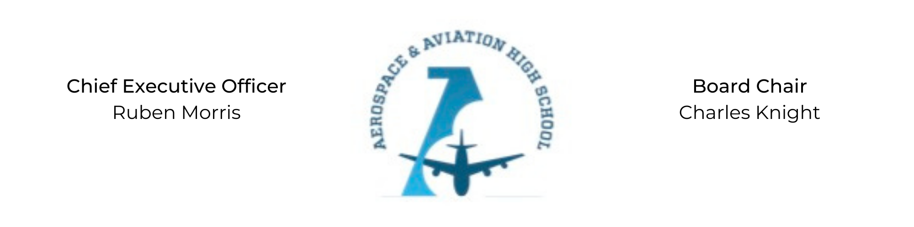
REGULAR MEETING OF THE BOARD OF DIRECTORS
Tuesday, August 23, 2022
3:30 PM
Minutes

- Call to Order - Chair Knight
  - Charles Knight called the meeting to order at 3:41 PM.
- Roll Call & Establishment of Quorum
Leadership and Board Members in attendance: Auri Brown, Courtney French, Charles Knight, Ruben Morris, Luis Pineda, Tramayne Russell, Merrick Sims, Phaye Wilson, Jillian Fitts (Assistant to the Board)
Guests: ET Brown (Advisory Board), Scott Underwood, Russell Raney (CFO), Melanie Haynes (NSFA)
Absent: Jeff Smith, R.J. Smith, Jeff Walker, and Tierra Wright
- Adoption of the Agenda
Auri Brown motioned to approve the August 23rd agenda. Phaye Wilson seconded and the motion carried.
- Adoption of the Minutes - July 19, 2022
Courtney French motioned to approve the July 19, 2022 minutes. Phaye Wilson seconded and the motion carried.
- Financial Report
Russell Raney, CFO of New Schools for Alabama, presented the budget
- Consent Calendar
  - Resolution 2022-11 - Resolution to approve the financial report.
- Resolutions for Consideration and Approval
  - 2022-11 - Tramayne Russell motioned to approve the 2022-11 resolution to approve the financial report and was seconded by Merrick Sims. The motion passed.
- Old Business
No old business.
- New Business
No new business.
- Adjournment
Phaye Wilson motioned to adjourn, seconded by Courtney French. The motion was carried and the meeting adjourned at 4:48 PM.

Respectfully submitted,
Jillian L. Fitts

Approved by: Approved by:

________________________________ _________________________________
Board Chairman Board Secretary

