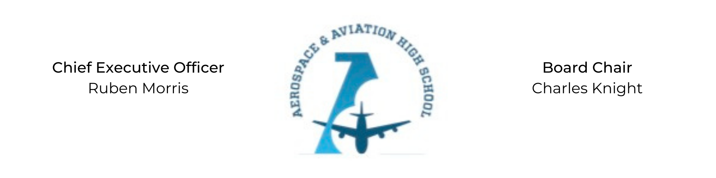
REGULAR MEETING OF THE BOARD OF DIRECTORS
Tuesday, October 26, 2021
3:30 PM
Minutes

- Call to Order - Chair Knight
  - Charles Knight called the meeting to order at 3:30 PM.
- Roll Call & Establishment of Quorum
Leadership and Board Members attending virtually: Auri Brown, Courtney French, Charles Knight, Ruben Morris, R.J. Smith, and Tiffany Storey
Guests Present: Scott Burnett (architect), Jeff Smith
Absent: Meghan Jones, Tramayne Russell, Merrick Sims, Jeff Walker, and Tierra Wright
- Adoption of the Agenda
Courtney French motioned to approve the October 26th agenda. R.J. Smith seconded and the motion carried.
- Adoption of the Minutes - September 28, 2021
Tiffany Storey motioned to approve the September 28th minutes. Courtney French seconded and the motion carried.
- Special Presentation/Facility Update
Temporary and permanent facility updates presented by Scott Burnett from CCR Architecture & Interiors.
- Financial Report
Financial update given by Ruben Morris and R.J. Smith.
- Chief Executive Officer’s Report
- Consent Calendar
  - Resolution 2021-9 - Approval of a resolution to nominate Jeff Smith to the AAHS Board of Directors starting November 1, 2021.
  - Resolution 2021-10 - Approval of a resolution to approve the updated Charter School contract.
  - Resolution 2021-11 - Approval of a resolution to enter into contract with Powerschool.
  - Resolution 2021-12 - Approval to craft a resolution for Employer Pay-In.
- Resolutions for Consideration and Approval
  - 2021-9 - Courtney French moved to approve the 2021-9 resolution to nominate Jeff Smith to the AAHS Board of Directors and was seconded by Auri Brown. The motion was carried unanimously.
  - 2021-10 - R.J. Smith motioned to approve the 2021-10 resolution to approve the updated Charter School contract and was seconded by Auri Brown. The motion was carried unanimously.
  - 2021-11 - R.J. Smith motioned to approve the 2021-11 resolution to enter into contract with Powerschool and was seconded by Tiffany Storey. The motion was carried unanimously.
  - 2021-12 - Auri Brown motioned to craft a resolution for Employer Pay-In and was seconded by Courtney French. The motion carried.
- Old Business
No old business.
- New Business
Meghan Jones will be stepping down from her position on the Board, effective November 1, 2021.
- Adjournment
Courtney French motioned to adjourn, seconded by R.J. Smith. The motion was carried and the meeting adjourned at 4:31 PM.

Respectfully submitted,
Jillian L. Fitts

Approved by: Approved by:

________________________________ _________________________________
Board Chairman Board Secretary

