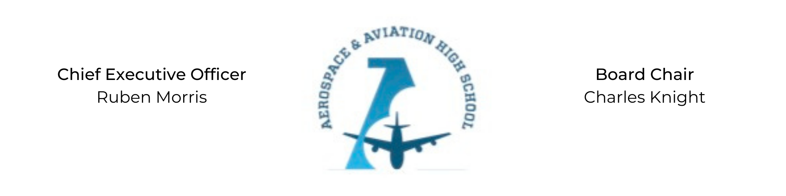
REGULAR MEETING OF THE BOARD OF DIRECTORS
Tuesday, January 31, 2022
3:30 PM
Minutes

- Call to Order - Chair Knight
  - Charles Knight called the meeting to order at 3:35 PM.
- Roll Call & Establishment of Quorum
Leadership and Board Members attending virtually: Charles Knight, Ruben Morris, Merrick Sims, Jeff Smith, R.J. Smith, Tiffany Storey, and Tierra Wright
Absent: Auri Brown, Courtney French, Tramayne Russell, and Jeff Walker
- Adoption of the Agenda
Merrick Sims motioned to approve the January 31st agenda. R.J. Smith seconded and the motion carried.
- Adoption of the Minutes - November 30, 2021
Tiffany Storey motioned to approve the November 30th minutes. Merrick Sims seconded and the motion carried.
- Financial Report
- Chief Executive Officer’s Report
- Consent Calendar
None
- Resolutions for Consideration and Approval
None
- Old Business
No old business.
- New Business
Next month’s meeting TBD.
- Adjournment
Charles Knight motioned to adjourn, seconded by Tiffany Storey. The motion was carried and the meeting adjourned at 3:50 PM.

Respectfully submitted,
Jillian L. Fitts

Approved by: Approved by:

________________________________ _________________________________
Board Chairman Board Secretary

