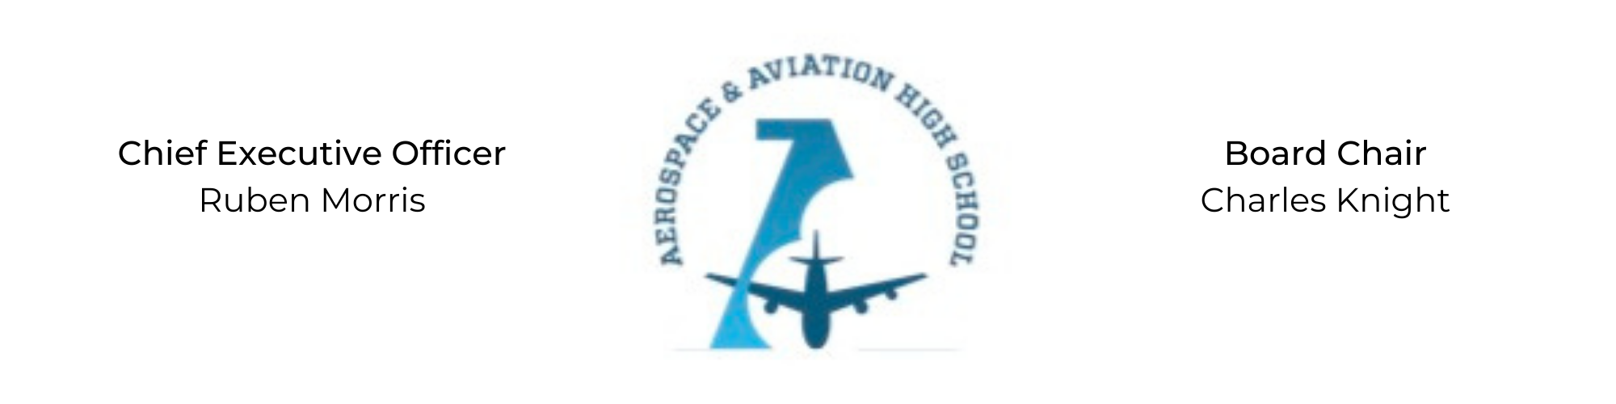
REGULAR MEETING OF THE BOARD OF DIRECTORS
Tuesday, September 28, 2021
3:30 PM
Minutes

- Call to Order - Chair Knight
  - Charles Knight called the meeting to order at 3:30 PM.
- Roll Call & Establishment of Quorum
Leadership and Board Members attending virtually: Auri Brown, Courtney French, Charles Knight, Ruben Morris, Tramayne Russell, Merrick Sims, and Tiffany Storey
Absent: Meghan Jones, R.J. Smith, Jeff Walker, and Tierra Wright
- Adoption of the Agenda
Tiffany Storey motioned to approve the September 28th agenda. Tramayne Russell seconded and the motion carried.
- Adoption of the Minutes - September 1, 2021
Tramayne Russell motioned to approve the September 1st minutes. Merrick Sims seconded and the motion carried.
- Financial Report
Financial update given by Ruben Morris
- Chief Executive Officer’s Report
  - Temporary Facility Update: Negotiating the contract with Fountain of Youth Church and gathering estimates for renovations.
  - Permanent Facility Update: Exploring possible location, grant options for funding and gathering estimates for development.
- Consent Calendar
  - Resolution 2021-7 - Approval of a resolution to contract the services of CCR Architecture & Interiors.
  - Resolution 2021-8 - Approval of a resolution to approve participation in the Teachers’ Retirement System.
- Resolutions for Consideration and Approval
  - 2021-7 - Tiffany Storey moved to approve the 2021-7 resolution to approve treasurer’s report and was seconded by Merrick Sims. The motion was carried unanimously.
  - 2021-8 - Tramayne Russell motioned to approve the 2021-8 resolution to approve participation in the Teachers’ Retirement System and was seconded by Merrick Sims. The motion was carried unanimously.
- Old Business
No old business.
- New Business
Next month’s meeting TBD.
- Adjournment
Courtney French motioned to adjourn, seconded by Tiffany Storey. The motion was carried and the meeting adjourned at 4:50 PM.

Respectfully submitted,
Jillian L. Fitts

Approved by: Approved by:

________________________________ _________________________________
Board Chairman Board Secretary

