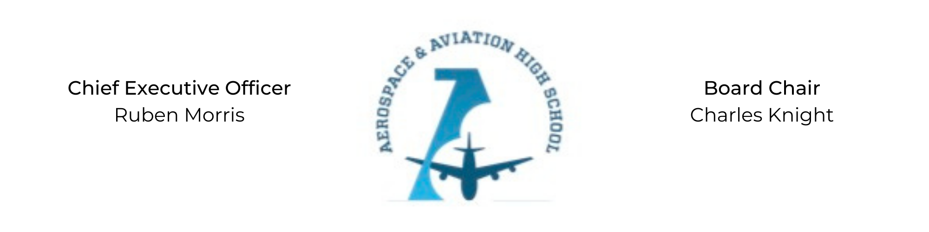
REGULAR MEETING OF THE BOARD OF DIRECTORS
Tuesday, September 1, 2021
3:30 PM
Minutes

- Call to Order - Chair Knight
  - Charles Knight called the meeting to order at 3:36 PM.
- Roll Call & Establishment of Quorum
Leadership and Board Members attending virtually: Auri Brown, Charles Knight, Ruben Morris, Tramayne Russell, R.J. Smith, Jeff Walker and Tierra Wright
Absent: Courtney French, Meghan Jones, Merrick Sims, and Tiffany Storey
- Adoption of the Agenda
R.J. Smith motioned to approve the September 1st agenda. Tierra Wright seconded and the motion carried.
- Adoption of the Minutes - July 27, 2021
Tramayne Russell motioned to approve the July 27th minutes. Auri Brown seconded and the motion carried.
- Financial Report
Treasurer’s report given by Ruben Morris.
- Chief Executive Officer’s Report
  - Charter Application Update: Negotiate the academic and financial responsibilities of the charter which are negotiated every 5 years.
  - Facility Update: Letter of intent signed with Fountain of Youth Church while we build our own facility. Any renovation costs of our temporary facility will be negotiated into monthly rent.
- Consent Calendar
  - Resolution 2021-6 - Approval of a resolution to approve the treasurer’s report.
- Resolutions for Consideration and Approval
R.J. Smith moved to approve the 2021-6 resolution to approve treasurer’s report and was seconded by Tramayne Russell. The motion was carried.
- Old Business
No old business.
- New Business
Next month’s meeting TBD.
- Adjournment
Jeff Walker motioned to adjourn, seconded by R.J. Smith. The motion was carried and the meeting adjourned at 4:12 PM.

Respectfully submitted,
Jillian L. Fitts

Approved by: Approved by:

________________________________ _________________________________
Board Chairman Board Secretary

