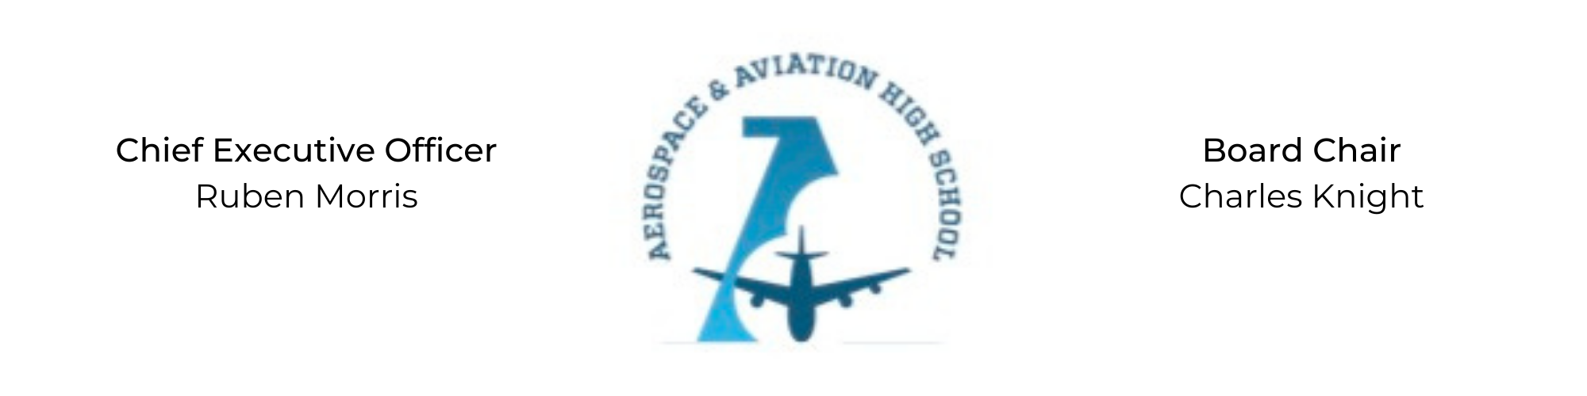
REGULAR MEETING OF THE BOARD OF DIRECTORS
Tuesday, June 9, 2022
3:30 PM
Minutes

- Call to Order - Chair Knight
  - Charles Knight called the meeting to order at 3:31 PM.
- Roll Call & Establishment of Quorum
Leadership and Board Members in attendance: Auri Brown, Courtney French, Charles Knight, Ruben Morris, Jeff Smith, Tiffany Storey, Tierra Wright, Jillian Fitts (Assistant to the Board)
Absent: Tramayne Russell, Merrick Sims, R.J. Smith, and Jeff Walker
- Adoption of the Agenda
Auri Brown motioned to approve the June 9th agenda. Tierra Wright seconded and the motion carried.
- Adoption of the Minutes - May 10, 2022
Minutes have been tabled.
- Consent Calendar
  - Resolution 2022-4 - Approval to craft a resolution to contract services with School Transportation Services, Inc.
  - Resolution 2022-5 - Approval to craft a resolution to contract food services with SLA Management, Inc.
- Resolutions for Consideration and Approval
  - 2022-4 - Jeff Smith moved to approve crafting a resolution to contract with School Transportation Services, Inc and was seconded by Auri Brown. The motion was carried unanimously.
  - 2022-5 - Tiffany Storey motioned to approve crafting a resolution to contract with SLA Management, Inc, and was seconded by Tierra Wright. The motion was carried unanimously.
- Old Business
No old business.
- New Business
In the process of creating financial and employment policies to be shared with the Board during the August meeting.
- Adjournment
Jeff Walker motioned to adjourn, seconded by Courtney French. The motion was carried and the meeting adjourned at 4:13 PM.

Respectfully submitted,
Jillian L. Fitts

Approved by: Approved by:

________________________________ _________________________________
Board Chairman Board Secretary

