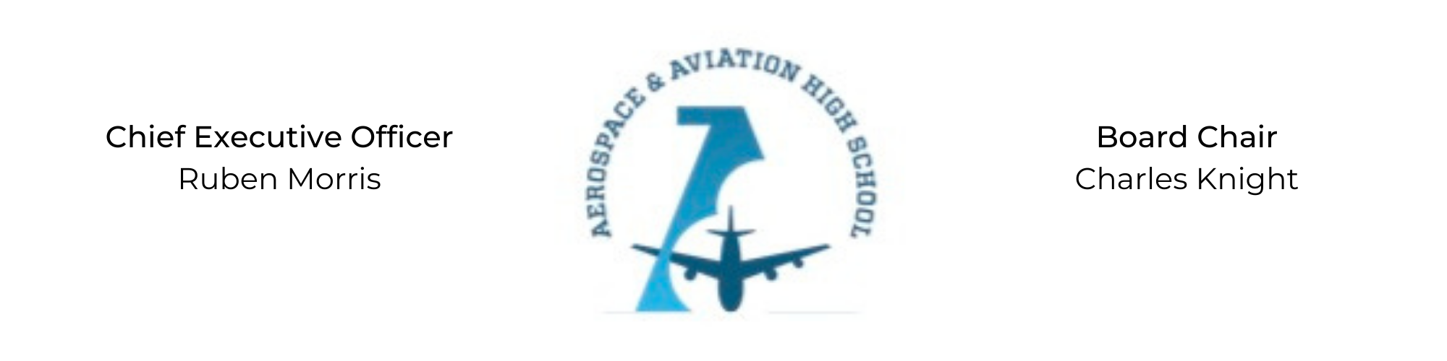
REGULAR MEETING OF THE BOARD OF DIRECTORS
Tuesday, May 10, 2022
3:30 PM
Minutes

- Call to Order - Chair Knight
  - Charles Knight called the meeting to order at 3:40 PM.
- Roll Call & Establishment of Quorum
Leadership and Board Members in attendance: Charles Knight, Ruben Morris, Tramayne Russell, Merrick Sims, Jeff Smith, R.J. Smith, Jeff Walker, Tiffany Storey, and Jillian Fitts (Assistant to the Board)
Absent: Auri Brown, Courtney French, and Tierra Wright
- Adoption of the Agenda
Jeff Smith motioned to approve the May 10th agenda. R.J. Smith seconded and the motion carried.
- Adoption of the Minutes - April 5, 2021
Minutes have been tabled.
- Financial Report
- Chief Executive Officer’s Report
- Consent Calendar
  - Resolution 2022-1 - Approval to craft a resolution for back office accounting services with New Schools for Alabama for the next 5 years.
  - Resolution 2022-2 - Approval of a resolution to enter into a 5-year professional services contract with New Schools for Alabama.
  - Resolution 2022-3 - Approval of a resolution to approve the salary schedule for the 2022-2023 school year.
- Resolutions for Consideration and Approval
  - 2022-1 - Jeff Walker moved to approve the 2022-1 resolution to craft a resolution for back office accounting services with New Schools for Alabama and was seconded by Jeff Smith. The motion was carried unanimously.
  - 2022-2 - Tiffany Storey motioned to approve the 2022-2 resolution to contract services with New Schools for Alabama and was seconded by R.J. Smith. The motion was carried unanimously.
  - 2022-3 - Jeff Smith motioned to approve the 2022-2 resolution to approve the 2022-2023 school year salary schedule and was seconded by Jeff Walker. The motion was carried unanimously.
- Old Business
No old business.
- New Business
Next month’s meeting TBD.
- Adjournment
Jeff Walker motioned to adjourn, seconded by Jeff Smith. The motion was carried and the meeting adjourned at 4:48 PM.

Respectfully submitted,
Jillian L. Fitts

Approved by: Approved by:

________________________________ _________________________________
Board Chairman Board Secretary

