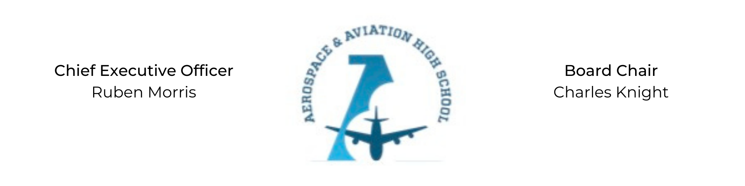
REGULAR MEETING OF THE BOARD OF DIRECTORS
Tuesday, May 25, 2021
3:30 PM
Minutes

- Call to Order - Chair Knight
  - Charles Knight called the meeting to order at 3:35 PM.
- Roll Call & Establishment of Quorum
Leadership and Board Members attending virtually: Auri Brown, Charles Knight, Ruben Morris, Tramayne Russell, Merrick Sims, R.J. Smith, and Tiffany Storey
Absent: Courtney French, Meghan Jones, and Tierra Wright
- Adoption of the Agenda
Tramayne Russell motioned to approve the May 25th agenda. R.J. Smith seconded and the motion carried.
- Adoption of the Minutes - April 20, 2021
Approval of the minutes have been tabled.
- Financial Report
Ruben Morris presented the summer budget proposal.
- Chief Executive Officer’s Report
- Consent Calendar
  - Resolution 2021-4 - Approval of a resolution to approve the 2021 summer budget.
- Resolutions for Consideration and Approval
R.J. Smith moved to approve the 2021-4 resolution to approve the 2021 summer budget and was seconded by Tramayne Russell. The motion was carried.
- Old Business
No old business.
- New Business
Next month’s meeting TBD.
- Adjournment
Tiffany Storey motioned to adjourn, seconded by R.J. Smith. The motion was carried and the meeting adjourned at 4:35 PM.

Respectfully submitted,
Jillian L. Fitts

Approved by: Approved by:

________________________________ _________________________________
Board Chairman Board Secretary

