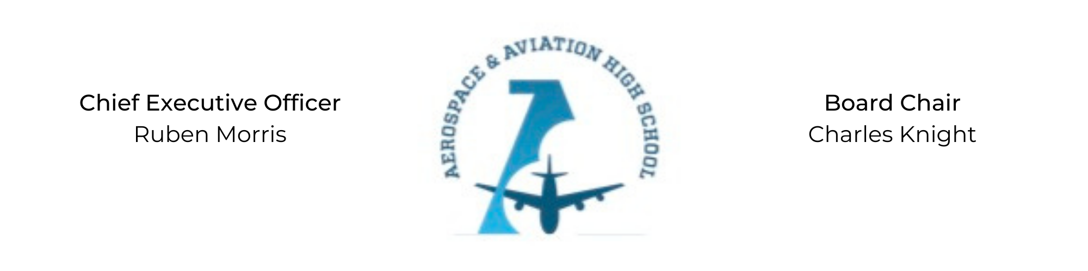
REGULAR MEETING OF THE BOARD OF DIRECTORS
Tuesday, November 17, 2020
3:30 PM
Minutes

- Call to Order - Chair Knight
  - Charles Knight called the meeting to order at 3:30 PM.
- Roll Call & Establishment of Quorum
Leadership and Board Members attending virtually: Courtney French, Meghan Jones, Charles Knight, Ruben Morris, Tramayne Russell, Merrick Sims, Tiffany Storey, and Tierra Wright
Absent: Auri Brown, R.J. Smith
- Adoption of the Agenda
Tiffany Storey motioned to approve the November 17 agenda. Courtney French seconded and the motion carried.
- Adoption of the Minutes - October 27, 2020
Courtney French moved to approve the October minutes, Tiffany Storey seconded and the motion carried.
- Financial Report
Tramayne Russell moved to approve the expense report, Merrick Sims seconded and the motion carried.
- Chief Executive Officer’s Report
- School Update: Charter application due November 30.
- Advisory Board Update: Larry Powell with Blue Origin and Dereck Murphy with the BWWB joined the Advisory Board.
- Consent Calendar
  - Resolution 2020-3 - Approval of a resolution to enter into a contract with BWC to secure land and funds for future campus.
  - Resolution 2020-4 - Approval of a resolution to enter into contract with Aderholt & Horton accounting firm.
  - Resolution 2020-5 - Approval of a resolution to ratify Ruben Morris’ CEO employment contract.
- Resolutions for Consideration and Approval
  - Tiffany Storey moved to approve the 2020-3 resolution to enter into a contract with BWC and seconded by Tramayne Russell. The motion was carried unanimously.
  - Tiffany Storey moved to approve the 2020-4 resolution to enter into a contract with Aderholt & Horton and seconded by Tramayne Russell. The motion was carried unanimously.
  - Courtney French moved to approve the 2020-5 resolution to ratify Ruben Morris’ contract for CEO and seconded by Tierra Wright. The motion was carried unanimously.
- Old Business
No old business.
- New Business
Next month’s meeting will be Tuesday, December 15th at 3:30 PM.
- Adjournment
Charles Knight motioned to adjourn, seconded by Tramayne Russell. The motion was carried and the meeting adjourned at 4:15 PM.

Respectfully submitted,
Jillian L. Fitts

Approved by: Approved by:

________________________________ _________________________________
Board Chairman Board Secretary

