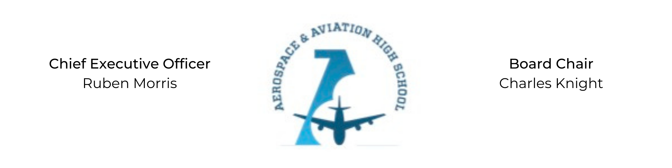
REGULAR MEETING OF THE BOARD OF DIRECTORS
Tuesday, December 15, 2020
3:30 PM
Minutes

- Call to Order - Chair Knight
  - Charles Knight called the meeting to order at 3:40 PM.
- Roll Call & Establishment of Quorum
Leadership and Board Members attending virtually: Courtney French, Meghan Jones, Charles Knight, Ruben Morris, Merrick Sims, R.J. Smith, and Tiffany Storey
Absent: Tramayne Russell and Tierra Wright
- Adoption of the Agenda
R.J. Smith motioned to approve the December 15 agenda. Merrick Sims seconded and the motion carried.
- Adoption of the Minutes - November 17, 2020
No errors or omissions on the November minutes.
- Financial Report
No financial report.
- Chief Executive Officer’s Report
- School Update: Charter application has been submitted. The next steps are a capacity interview, a public hearing and then the official vote in January.
- Advisory Board Update: Two new advisory board members including Board Chair, Colonel Iyal Nyals and CEO of Kaiser Aircraft, Dorris Sewell. R.J. Smith will serve as liaison between the Governing and Advisory Board.
- Consent Calendar
None
- Resolutions for Consideration and Approval
None
- Old Business
No old business.
- New Business
Next month’s meeting TBD.
- Adjournment
R.J. Smith motioned to adjourn, seconded by Tiffany Storey. The motion was carried and the meeting adjourned at 4:25 PM.

Respectfully submitted,
Jillian L. Fitts

Approved by: Approved by:

________________________________ _________________________________
Board Chairman Board Secretary

