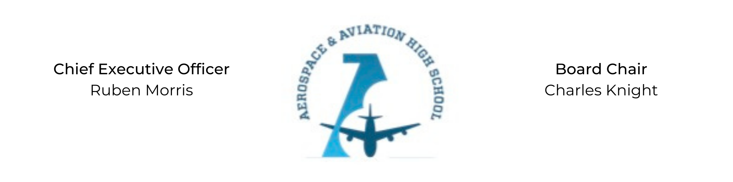
REGULAR MEETING OF THE BOARD OF DIRECTORS
Tuesday, November 30, 2021
3:30 PM
Minutes

- Call to Order - Chair Knight
Charles Knight called the meeting to order at 3:33 PM.
- Roll Call & Establishment of Quorum
Leadership and Board Members attending virtually: Courtney French, Charles Knight, Ruben Morris, Merrick Sims, Jeff Smith, R.J. Smith, and Tiffany Storey
Absent: Auri Brown, Tramayne Russell, Jeff Walker, and Tierra Wright
- Adoption of the Agenda
Courtney French motioned to approve the November 30th agenda. R.J Smith seconded and the motion carried.
- Adoption of the Minutes - October 26, 2021
R.J. Smith motioned to approve the October 26th minutes. Merrick Sims seconded and the motion carried.
- Financial Report
- Chief Executive Officer’s Report
  - Temporary Facility Update: We have executed a 2-year lease with a 3rd year option to renew with the Fountain of Life Church.
  - Permanent Facility Update: Expecting renderings of the facility at the beginning of the new year.
  - Grant Funding Update
- Consent Calendar
None
- Resolutions for Consideration and Approval
None
- Old Business
No old business.
- New Business
Next month’s meeting TBD.
- Adjournment
Charles Knight motioned to adjourn. No objections. The meeting adjourned at 4:01 PM.

Respectfully submitted,
Jillian L. Fitts

Approved by: Approved by:

________________________________ _________________________________
Board Chairman Board Secretary

