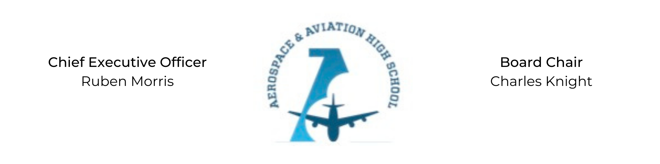
REGULAR MEETING OF THE BOARD OF DIRECTORS
Tuesday, June 22, 2021
3:30 PM
Minutes

- Call to Order - Chair Knight
  - Charles Knight called the meeting to order at 3:33 PM.
- Roll Call & Establishment of Quorum
Leadership and Board Members attending virtually: Auri Brown, Charles Knight, Ruben Morris, Tramayne Russell, Jeff Walker and Tiffany Storey
Absent: Courtney French, Meghan Jones, Merrick Sims, R.J. Smith, and Tierra Wright
- Adoption of the Agenda
Auri Brown motioned to approve the June 22nd agenda. Tiffany Storey seconded and the motion carried.
- Adoption of the Minutes - May 25, 2021
Tiffany Storey motioned to approve the May 25th minutes. Jeff Walker seconded and the motion carried.
- Financial Report
Ruben Morris presented the financial report.
- Chief Executive Officer’s Report
  - Charter Application Update: The Public Charter Commission has approved a summer application cycle. We will open in the Fall of 2022 in Bessemer.
  - Summer Camp Update: Camp is held Tues, Weds, and Thurs at various YMCA and Boys & Girls Clubs around towns.
  - Facility Update: Exploring building at the Bessemer Airport.
- Consent Calendar
  - Resolution 2021-5 - Approval of a resolution to approve new advisory board members.
- Resolutions for Consideration and Approval
Auri Brown moved to approve the 2021-5 resolution to approve the new advisory board members and was seconded by Tiffany Storey. The motion was carried.
- Old Business
No old business.
- New Business
Next month’s meeting TBD.
- Adjournment
Jeff Walker motioned to adjourn, seconded by Auri Brown. The motion was carried and the meeting adjourned at 4:08 PM.

Respectfully submitted,
Jillian L. Fitts

Approved by: Approved by:

________________________________ _________________________________
Board Chairman Board Secretary

