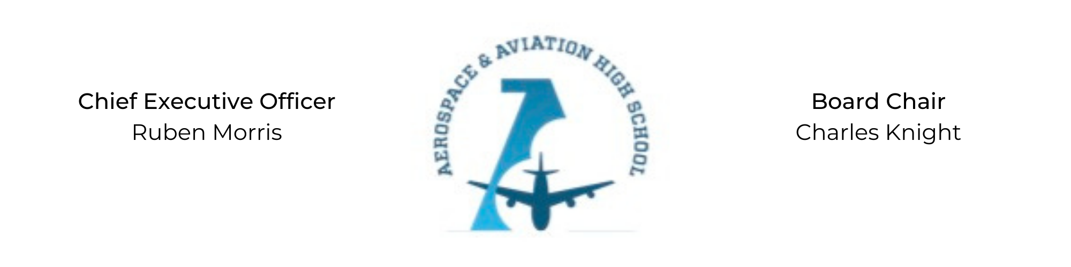
REGULAR MEETING OF THE BOARD OF DIRECTORS
Tuesday, July 19, 2022
3:30 PM
Minutes
- Call to Order - Chair Knight
  - Charles Knight called the meeting to order at 3:45 PM.
- Roll Call & Establishment of Quorum
Leadership and Board Members in attendance: Courtney French, Charles Knight, Ruben Morris, Luis Pineda, Jeff Smith, Tiffany Storey, Jillian Fitts (Assistant to the Board)
Guests: Sajan Philip and Chris Reynolds
Absent: Auri Brown, Tramayne Russell, Merrick Sims, R.J. Smith, Jeff Walker, and Tierra Wright
- Adoption of the Agenda
Tiffany Storey motioned to approve the July 19th agenda. Courtney French seconded and the motion carried.
- Adoption of the Minutes - May 10 & June 9, 2022
Jeff Smith motioned to approve the May 10 and June 9, 2022 minutes. Courtney French seconded and the motion carried.
- Financial Report
- Consent Calendar
  - Resolution 2022-6 - Resolution to approve the financial report.
  - Resolution 2022-7 - Resolution to approve entering into a 2-yr lease with a 3-yr extension with the Fountain of Life Church and execution of the loan with Hope Credit Union.
  - Resolution 2022-8 - Resolution to approve opening a 10th grade section for the 2022-2023 school year at AAHS.
  - Resolution 2022-9 - Approve resolution to enter into a 3-yr contract with School Transportation Services, Inc (STS).
  - Resolution 2022-10 - Approve resolution to enter into a mutually binding contract with SLA Management, Inc for food services.
- Resolutions for Consideration and Approval
  - 2022-6 - Tiffany Storey moved to approve the 2022-6 resolution to approve the financial report and was seconded by Jeff Smith. The motion passed.
  - 2022-7 - Jeff Smith motioned to approve the 2022-7 resolution to enter into a 2-yr lease with a 3-yr extension with the Fountain of Life Church and execute the loan with Hope Credit Union and was seconded by R.J. Smith. The motion passed unanimously.
  - 2022-8 - Tiffany Storey moved to approve the 2022-8 resolution to approve opening a 10th grade section for the ‘22-’23 school year and was seconded by R.J. Smith. The motion passed unanimously.
  - 2022-9 - Courtney French moved to approve the 2022-9 resolution to contract services with STS and was seconded by Jeff Smith. The motion passed.
  - 2022-10 - Jeff Smith motioned to approve the 2022-10 resolution to contract services of SLA Management and was seconded by Tiffany Storey. The motion passed unanimously.
- Old Business
No old business.
- New Business
Tiffany Storey will be stepping down from her position on the Board to pursue a professional services contract with AAHS. Ruben nominated Phaye Wilson as the new parent board member.
- Adjournment
Jeff Smith motioned to adjourn, seconded by R.J. Smith. The motion was carried and the meeting adjourned at 4:57 PM.

Respectfully submitted,
Jillian L. Fitts

Approved by: Approved by:

________________________________ _________________________________
Board Chairman Board Secretary

