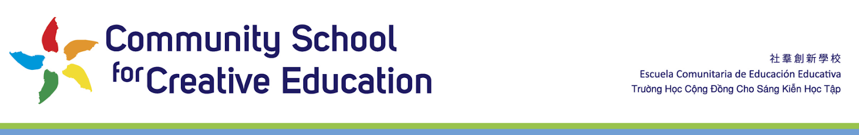2111 International Boulevard Oakland, CA 94606 510.686.4131 info@communityschoolforcreativeeducation.org

Community School of Creative Education
Administrative Salary Schedule

New  1- 3 years | Experienced  4+ year
$107,000- $117,000 | $117,000- $127,000

Subject to 4% increase each year.

