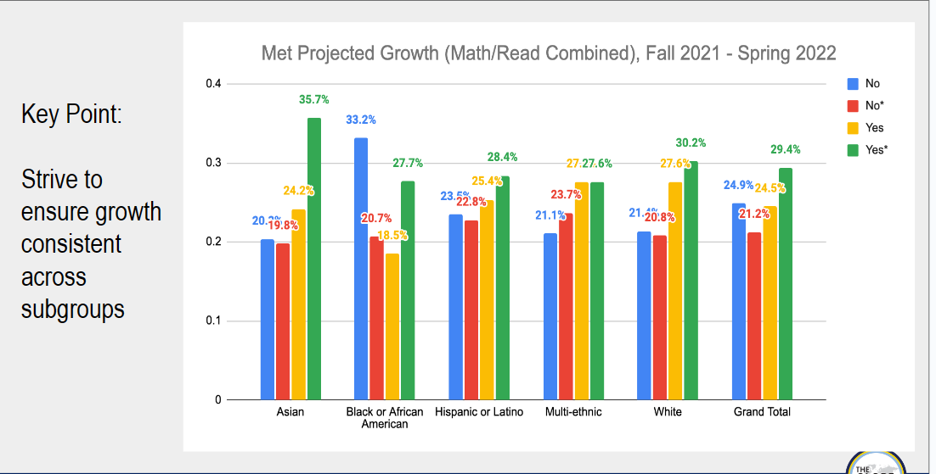

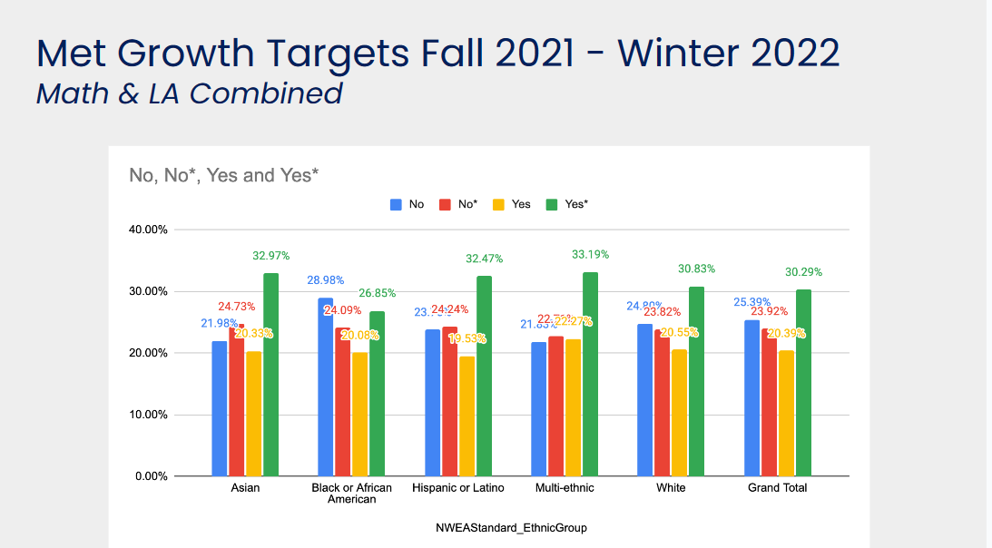

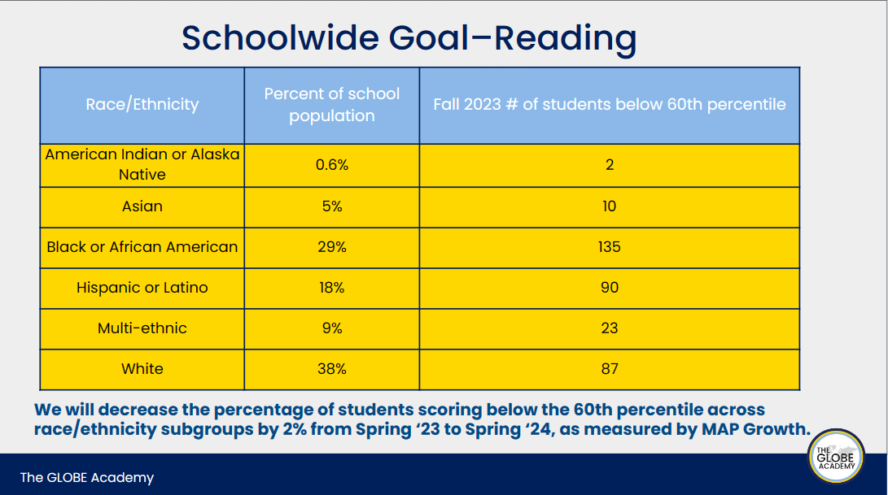
What this means in real numbers: Out of ~1,051 students, nearly half of two traditionally marginalized racial score less than the 60th percentile.
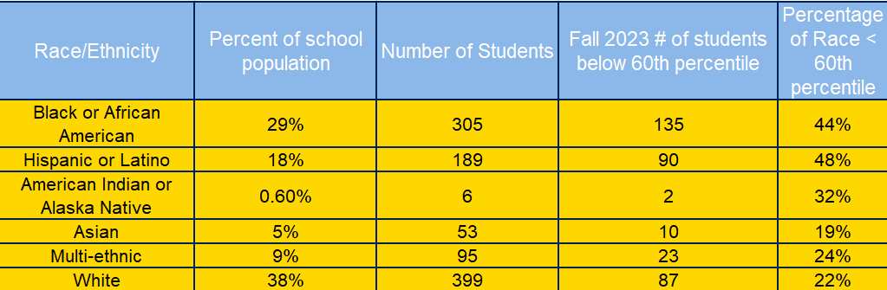

This has been consistent with GLOBE for the past several years.
Questions:
- Are there particular themes of questions that these groups consistently perform poorly on?
- Are the students completing the test in time? Are they penalized for not finishing on time?
- It is understood that the detailed family report may be a challenge to provide to all students. However, for those who are scoring below the 60th percentile, can they receive the detailed report?
  - Parents should be given the opportunity to be involved so they can support what the students are learning at school. They should not rely solely on the teacher to nurture a successful MAP testing experience.
