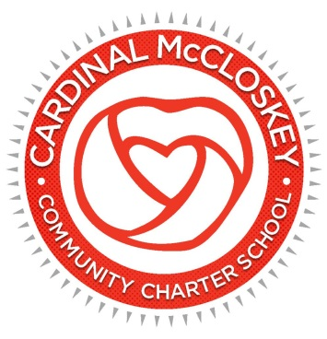

**Cardinal McCloskey Charter School**

**Board of Trustees**

**Board Meeting Special Meeting Minutes**

**August 30, 2021**

1. The meeting was called to order by Phyllis Thorne, Chairperson, at 6:09 p.m. Public participation was

available at 685 East 182nd Street, Bronx, NY, 115 E. Stevens Avenue, Valhalla, NY and 330 East 75th

Street, New York, NY.

1. **Attendance** taken by Dr. Reva Gershen-Lowy

**Present:** Ms. PhyllisThorne,Mr. Peter Quinn, Ms. Joy DeVries,Mr.Jim McCarthy**,** Dr. William Ursillo, Dr. Reva Gershen-Lowy, Sister Patricia and Dunica Charles

**Charter School Staff:** Ms**.** Jennifer Fedele, Frances Garcia, Grace Bendick and Desiree Grand

**Guests**: Susan Briggs

1. **Sanctuary Community meeting** was facilitated by Ms. Phyllis Thorne
2. **Motion to approve the agenda of the August 30, 2021 Special Board Meeting**

*A motion to approve the agenda of the August 30, 2021 Special Board Meeting was duly made by Jim McCarthy, seconded by Dr. William Ursillo and carried unanimously; the meeting was approved and accepted.*

1. **Discussion -** Mr. Peter Quinn provided an overview of the lease and highlighted how it would impact the school.

* The lease indicates the rent will increase by 3% each year. The Charter School will still be

entitled to the per pupil rate which is applied to the lease. Mr. Quinn noted the per pupil rate will not cover the entire cost of the rent and operating costs. Services such as elevator maintenance and boiler operating expenses will be shared between CMCS Head Start and the Charter School. The Charter School’s portion will be drawn down from savings. Mr. Quinn expressed the more we pay in operating expenses the less we have for the students. If CMCS Head Start does not renew their lease after two years the Charter School will be responsible for the upkeep of the entire building but on another note more grades will be added.

* The Board members also discussed who is responsible for the maintenance and repairs of the building. CMCS Head Start and the Charter School will share responsibility for 100% of the operating costs. Ms. Susan Briggs, CMCCS Attorney, stated the lease indicates the Landlord is responsible for all structural repairs and the Charter School is only responsible for the demised premises. Additional clarification and common language needs to be obtained with the Dominican Sisters regarding the lease.
* It is included in the lease that two personnel from Aquinas High School will continue to provide services in conjunction with CMCS Head Start sharing the expenses. Termination of these employees have to be agreed upon by both entities and salary can be adjusted (lease does not specify to keep at current rate).
* Charter School Institute (CSI) has to approve the lease agreement; execution can happen only if CSI approval is received.
* The Board members discussed the additional security deposit amount

1. **Action Items**

Process Funds for School

1. Incorporation
2. Preparation for 501c(3) – create a six-month timeline for next meeting
3. **Motion to approve the new Lease as modified -** Because of her affiliation with the Dominican Sisters, Sister Patricia recused herself from the approval of the new lease modifications. Dr. Reva

Gershen-Lowy requested a roll call vote.

*A motion to approve the new lease as modified was made by Phyllis Thorne, seconded by Peter Quinn, the motion was approved and accepted.*

1. **Motion to authorize Phyllis Thorne and Peter Quinn to represent the Charter School Board in finalizing details on the lease**

*A motion to authorize Phyllis Thorne and Peter Quinn to represent the Charter School Board in finalizing details on the lease, was made by Jim McCarthy, seconded by Dunica Charles, the motion was unanimously approved and accepted.*

1. **Public Participation – N/A**
2. **Adjournment**

*A motion duly made by Peter Quinn, seconded by Joy Devries and carried unanimously; the meeting was adjourned at 7:21 p.m.*