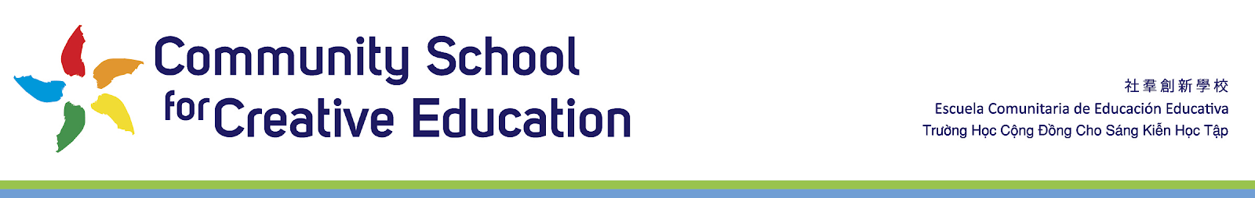
Community School for Creative Education (CSCE)
Academic Intervention Coordinator
Job Description
2022-2023
for approval
Reports to: CSCE Assistant Head of School
Overview:
Under the direction of the Assistant Head of Schools, the Academic Intervention Coordinator oversees and provides support to general education teachers and support staff to facilitate student academic and behavioral growth. The Academic Intervention Coordinator is responsible for providing support to general education teachers and staff to develop and implement effective classroom strategies and programs for students demonstrating academic and behavioral challenges.
Key responsibilities:
- Support teachers, administrators, and support staff in implementing Student Success Team (SST) recommendations, classroom behavior management techniques and universal screening process
- Support school sites in the implementation of systems to track/record data
- Support classroom teachers with the interpretation of data related to interventions in an effort to meet the needs of individual students
- Assist in the evaluation of classroom interventions and/or individual student interventions
- Make recommendations for improvements to interventions currently being implemented or that should be implemented
- Serve as a resource to classroom teachers to help students achieve academically and behaviorally
- Work with classroom teachers to monitor student progress
- Consult with curriculum committees studying such topics as textbook selection, vocabulary development, concept development, supplementary materials, and the development of study skills
- Perform other duties as assigned
Optimal Qualifications: CSCE’s Academic Intervention Specialist will poses most or preferably all of the following:
- Bachelor's degree (MA/MS degree preferred)
- Appropriate Special Education teaching credential
- Cares about children, their academic success, and their social and emotional well-being
- Knowledge of curriculum development
- Broad teaching experience
- Ability to work collaboratively with people, providing leadership and coaching
- Facilitate and coordinate multiple tasks simultaneously
- Knowledge of the planning, organization, and implementation of the assigned programs of CSCE improvement support services
- Knowledge of curriculum and instruction
- Knowledge of methods and procedures utilized in the development and implementation of performance criteria for programs, projects, and services for the District/school improvement support services
- Knowledge of National research-based educational programs and instructional strategies
- Ability to identify struggling learners and provide targeted support based upon student needs
- Ability to communicate effectively both orally and in writing
- Ability to interact with others respectfully, using tact, patience, and courtesy
- Ability to prepare presentations using assigned software and other media
- Ability to interpret, apply, and explain rules, regulations, policies, and procedures
- Ability to establish and maintain cooperative and effective working relationship with others
- Ability to operate a computer and assigned office equipment
- Ability to meet schedules and timelines
Working Conditions:
- Subject to classroom/office environment and community settings, which may include inside and outside environment conditions
- Subject to travel between sites
Physical Conditions:
  - Visual capability to read handwritten or typed documents, and the display screen of various office equipment and machines
  - Able to conduct a verbal conversation
  - Able to hear normal range verbal conversation (approx. 60 decibels)
  - Able to sit, stand, stoop, kneel, bend, and walk
  - Able to sit for sustained periods of time
  - Able to climb slopes, stairs, steps and ladders
  - Able to lift up to 25 pounds
  - Able to carry up to 25 pounds

