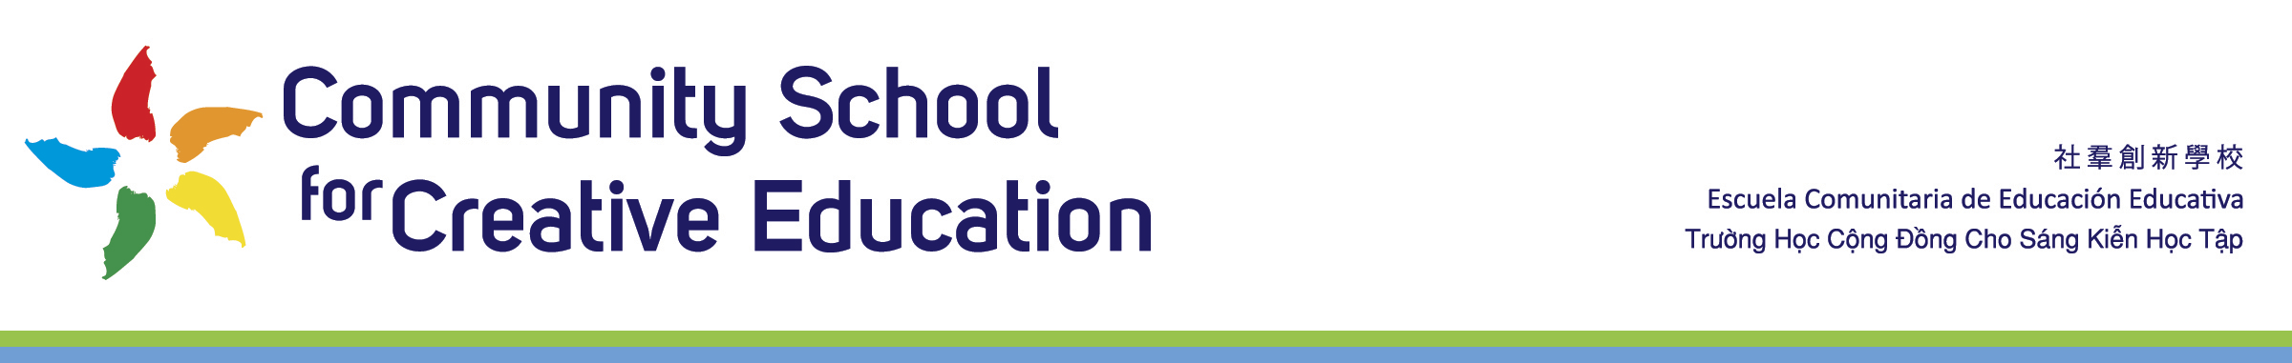

Community School for Creative Education
Board Calendar 2021-2022
DRAFT for Board Approval

Location:
Community School for Creative Education
2111 International Blvd
Oakland, CA 94606
Tel: 510 636 4131

ZOOM Link
For ZOOM Link Go To
https://app2.boardontrack.com/public/maUTAb/nextAgenda

Times:
All meetings held 6pm – 8pm

Dates:
Thursday, August 5, 2021

Thursday , September 2 , 2021

Thursday, October 7, 2021

Thursday November 4, 2021

Thursday, December 2, 2021

Thursday, January 13, 2022

Thursday, February 3, 2022

Thursday, March 3, 2022

Thursday, April 21, 2022

Thursday May 5, 2022

Saturday, June 18, 2022 9am – 1pm
Annual Retreat

Mark Your Calendars:
Friday, April 22, 2022 5pm – 8pm
CSCE Annual Dragon Gala Celebration & Fundraiser: Healthy Kids, Healthy Earth

